
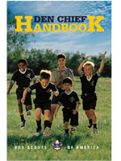

NCAC - VA Central
Den Chief Training

Appendix
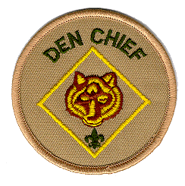

Den Chief Training Chair:

Roger Claff
reclaff@aol.com
A Very Brief List of Resources
For Cub Scout Den Activities and Events

- Den Chief Handbook.

- Cub Scout Songbook, Boy Scout Songbook, Group Meeting Sparklers.

- Cub Scout Magic.

- Cub Scout Program Helps.

- Cub Scout Tiger Cub, Wolf, Bear, Webelos Handbooks.

- Cub Scout Roundtable and Pow Wow Handouts.

- Cub Scout Leader How-to Book, Cub Scout Fun Book.

- Cub Scout Webelos Leader Guide.

- Cub Scout Academics and Sports Program Guide.

- Cub Scout Ceremonies for Dens and Packs.

- Cub Scout Grand Prix Pinewood Derby Guidebook.

- Boys’ Life magazine, Scouting magazine, Scouter Digest.

- Cub Scout Leader Book, Insignia Guide, Guide to Safe Scouting.

- Web Sites:
www.usscouts.org – This unbelievable site has almost everything.
www.usscouts.org/usscouts/bbugle.asp – Baloo’s Bugle on-line roundtable notes.
www.macscouter.com/Skits – MacScouter’s Big Book of Skits.

- Games, Skits, Cheers, etc., e.g., Need a Cheer? Find it Here!, All the Applauses We Could Find, Scout Skits/More Scout Skits, KISMIF Book of Youth Games, The Scout Puzzle and Activity Book, etc. Available through Honor Bookstore: www.scouting.com, or Derita Reporter: http://hometown.aol.com/deritarep/myhomepage/business.html.

- Campfire Songs, Irene Maddox and Rosalyn Cobb, Globe Pequot, Guilford, CT, 1998.

- Webelos Resource Book, Utah National Parks Council, BSA, 2004. Activity badge projects, etc.

- Best of the Leader Cut-Out Pages, Scouts Canada National Council, 1990. Skits, songs, games, etc.

- Magic Books, e.g., Mark Wilson’s Complete Course in Magic, Mark Wilson, Ottenheimer Publishers, Philadelphia, PA, 1988.

- Kite-building Books, e.g., Kites in the Classroom, Wayne Hosking, American Kitefliers Association, 1559 Rockville Pike, Rockville, MD, 20852-1651, 1992.

- Boy Scouts of America Workshop Book, Gene and Jody Malis, Berkley Publishing, New York, 1973. Out-of-print, but great resource for projects working with wood tools.

- Paper Airplane Books, e.g., How to Make and Fly Paper Airplanes, Captain Ralph S. Barnaby, Four Winds Press, New York, 1968.

- Science Experiment Books, e.g., 201 Awesome, Magical, Bizarre, and Incredible Experiments, Janice VanCleave, John Wiley and Sons, New York, 1994.

- Nature Books, e.g., 175 Amazing Nature Experiments, Rosie Harlow & Gareth Morgan, Random House, NY, 1991. Also Golden Guides/Golden Field Guides, Golden Press, NY.

- Chess Books, e.g., Chess for Children, Ted Nottingham, Bob Wade, and Al Lawrence, Sterling Publishing, New York, 1993.

- Puppet-making Books, e.g., Skits and Puppets, Pow Wow Series, Boy Scouts of America, North Brunswick, NJ, 1971.

- Crafts, e.g., The Best of Pack O’ Fun Wood Projects for Kids, Suzanne McNeill, Design Originals, Fort Worth, TX, 1997 (Pack O’ Fun magazine and booklets often carry Cub projects); Rainy Days and Saturdays, Linda Hetzer, Workman Publishing, New York, 1995; etc.

- Story Compilations, e.g., Trail and Campfire Stories, Julia M. Seton, Seton Village Press, Santa Fe, NM, 1968; Woodland Tales, Ernest Thompson Seton, Stevens Publishing, Kila, MT, 1992; Why the North Star Stands Still and Other Indian Legends, William R. Palmer, Zion Natural History Association, Springdale, UT, 1978.

- Flags, e.g., How to Display and Respect the Flag of the United States, United States Navy Recruiting Command.

- Hikes, e.g., Hikers Guide to the C&O Canal, and Mason-Dixon Council Cub Scout Hiking Trails, Mason-Dixon Council, BSA. Also Stone Bridge Trail at Manassas Battlefield Park, National Capital Area Council Troop 1182.

- Historical Landmarks, e.g., Mount Vernon Historic Activities for scouts, Mount Vernon Ladies’ Association.

- Award Recognitions for Cubs, e.g., Patch Place catalog, http://www.thepatchplace.com.

Den and Family Activities

Fairfax County "PARK TAKES," schedule of activities, call 324-8588 to order.

The Flying Circus, 1930's Barnstorming Air Show, Route 17, Bealton, $10 adults, $3 children, call for schedule, 540 439-8661.

Glen Echo Park, 7300 MacArthur Boulevard 301 492-6282, recording, 301 492-6663. Carousel, Adventure Theatre, and Puppet Company.

Historical Trails program. Brochure from Program Office at BSA HQ, Bethesda. Local area trails of various length and subject. Patches available for purchase upon completion of trail and questionnaire (the Alexandria patch is the nicest).

Journal Express Newspapers, 2720 Prosperity Avenue, 703 846-8395, ~ ages 8 and up. Free tours by appointment for groups of 10 or fewer.

Loudoun Times-Mirror, 9 East Market Street, 703 777-1111. Free tours by appointment Monday through Thursday from 8:30 to 5 p.m. for groups of 24 or fewer. See how a newspaper is put together, from the reporters to the presses. Ages 5 and up.
Mount Vernon Plantation. Free admission on third Monday in February. Can purchase patch on completion of historic trail. 703 780-2000.

National Building Museum, Judiciary Square, 202 272-2448 ext 3305 for Museum’s Scout Coordinator. (Article in Scouter Digest, Fall 1998. p. 23.)

The Newseum, 1101 Wilson Boulevard, 703 284-3700. Videotape of news segment costs $10. You can purchase a copy of newspaper headlines for the day you were born. Adjacent to the Newseum is Freedom Park, 'walk with Freedom." Brochure available.

Torpedo Factory, Alexandria 703 838-4565. Home to 150 artists, work in progress, talk with the artists.

United States Geological Survey, 12201 Sunrise Valley Drive, 703 648-4748, Tours. Call for reservations.

Wood Carving at Colvin Run Mill. 703 759-2771 for schedule and age requirements.

Tours, Places to See, Things to Do

All About Town 202-393-3896
Alexandria Parks 703-838 4343
Andrews Air Force Base 301-981-4511
Antietam Battlefield Historical Trail 301-739-1212
Arboretum (National Arboretum) 202-475-4815
Armed Forces Medical Museum, Walter Reed Medical Center 202-576-2348
Art Museum of the Americas 202-857-6583
Arthur M. Sackler Gallery 202-357-2020
Arts & Industries Building Museum 202-357-2020
Aquarium (Department of Commerce Building) 202-377-2825
Arlington House (Robert E. Lee House) 703-557-3154
Arlington Cemetery 703-557-0613
Botanic Garden 703-225-7099
Bureau of Engraving and Printing 202-447-9709
Capital Building Tours 202-225-6827
Capital Children's Museum 202-543-8600
Chesapeake & Ohio Canal 202-299-3622
Christmas Candlelight White House Tour 202-472-3669
Cara Barton House 202-492-6245
Coca Cola Bottling Plant, Alexandria Tour 703-820-2323
Colonial Annapolis Historical Trail 704-289-1604
Colvin Run Mill 703-759-2771
Corcoran Gallery of Art 202-638-3211
Cox Farms Pumpkin Patch - Braddock Road 703-830-4121
CSX Railroad (Formerly C & O Railroad) 703-589-2241
Daughters of the American Revolution Museum 202-628-1776
Decatur House 202-673-4030
Dial Audubon 301-652-1088
Dial-A-Museum 202-357-2020
Dial-A-Park 202-619-7275
Dial-A-Weather Forecast 202-936-1212
Doll's House and Toy Museum 202-244-0024
Dulles Airport Tours 703-471-7838
Dumbarton Oaks (Starting Place of the United Nations) 202-338-8278
Ellanor C. Lawrence Park 703-631-0013
Fairfax County Parks - General Information 703-246-5700
Federal Aviation Administration Control Center, Leesburg 703-783-0745
Federal Buildings - Visitors Information 202-728-4422
Federal Bureau of Investigation (Reservations 9 to 12 months in advance) 202-324-3447
Folger Shakespeare Library 202-544-7077
Ford's Theater 202-426-6924
Fort McHenry National Monument 410-962-4290
Franciscan Monastery 202-526-6800
Fredericksburg and Spotsylvania National Military Park 540-373-6122
Frederick Keys Baseball 301-662-0013
Freer Gallery of Art 202-357-2020
Frying Pan Park 703-437-9101
George Washington Masonic National Memorial 703-683-2007
Goddard Space Flight Center 301-286-8103
Great Falls Park, Virginia 703-759-2925
Great Falls Park, Maryland 301-299-2026
Gulf Branch Nature Center, Arlington (Gems and Indian Lore) 703-558-2340
Gunston Hall 703-550-9220
Hidden Oaks Nature Center, Annandale 703-941-5009
Hidden Pond Park Nature Center, West Springfield 703-451-9588
Hirshorn Museum 202-357-2700
Holocaust Museum 202-653-9219
International Visitors Information Service 202-783-6540
Intelsat Co. 703-488-2687
Interstate Van Lines (Donates $3 per Adult to Pack) 703-569-2121
Islamic Center 202-332-8343
Jefferson Memorial 202-619-7222
Kennedy Center for the Performing Arts – Tours 202-254-3850
Lake Accotink Park 703-569-3454
Lee's Boyhood Home, Alexandria 703-548-8454
Library of Congress 202-707-5458
Lincoln Memorial 202-619-7222
Long Branch Nature Center, Arlington 703-558-2741
Main Post Office 202-523-2001
Manassas National Battlefield Park (Stone Bridge Trail and Patch) 703-754-1861
Marine Corps Evening Parades - Iwo Jima Memorial 202-422-4173
Marine Corps Museum. Washington Navy Yard (Weekdays) 202-433-3840
Marine Corps Museum, Washington Navy Yard (Weekends) 202-433-3534
Maryland Science Center 410-685-2370
Mason District Park, Annandale 703-941-1730
Military Band Concerts 202-433-4011
Morven Park Plantation 703-777-2414
Mount Vernon 703-780-2000
Mount Vernon Historical Trail 703-780-2000
Museum of African Art 202-547-7424
Museum of American History 202-357-2700
National Airport 703-557-2045
National Archives 202-501-5000
National Aquarium 703-557-2043
National Arboretum 202-377-2825
National Building Museum 202-272-2448
National Capital Lincoln Trail 202-530-9360
National Cathedral 202-537-6200
National Colonial Farm, Accokeek, MD 301-283-2113
National Gallery of Art 202-737-4215
National Geographic Society - Explorer’s Hall 202 857-7000:
National Housing Center 202-452-0200
National Museum of American Art 202-357-1300
National Museum of Women in the Arts 202-783-5000
National Park Service 202-619-7222
National Portrait Gallery 202-357-1300
National Public Radio 202-822-2300
National Rifle Association - Firearms Museum 202-784-6505
National Shrine of the Immaculate Conception 202-526-8300
National Visitors Center 202-523-5033
National Zoological Park 202-673-4800
Naval Observatory Tours 202-653-1543
Navy Memorial (7th and Pennsylvannia Avenue) 202-737-2300
Navy Memorial (Concerts) 202-433-2525
Navy Memorial Museum, Washington Navy Yard, Visitor Center 202-433-2218
Navy Memorial Museum, Washington Navy Yard, 202-433-2651
Nottoway Park, Vienna 703-938-7532
Oatlands Plantation 703-777-3174
Octagon 202-638-3221
Old Stone House 202-426-6851
Organization of American States (OAS) 202-331-1010
Oxen Hill Children's Farm 301-839-1177
Patuxent National Wildlife Visitor Center 301-497-5886
Pentagon Tours 703-695-1776
Peterson House 703-426-6830
Pierce Mill 703-426-6830
Pohick Regional Park (Good for Winter Sledding) 703-339-6100
Potomac Appalachian Trail Club 703-638-5306
Potomac Nationals Baseball 703-590-2311
Potomac River Power Plant, Alexandria 703-872-3571
Prince William Forest National Park, Triangle, Virginia 703-221-7181
Riverbend Interpretive Center, Great Falls, Virginia 703-759-3211
Scottish Walk (First Saturday in December, Scout Units Participate) 703-838-4200
Smithsonian Museums 202-381-6264
Smithsonian Museum - Air and Space 202-357-2700
Smithsonian Museums - Natural History 202-357-2700
State Department 202-647-3241
Sully Plantation 703-437-1794
Supreme Court of the United States 202-252-3211
Textile Museum 202-667-0441
The American Sailor Evening Concerts 202-433-2218
Theodore Roosevelt Island 703-285-2601
Thomas Jefferson Memorial 202-426-6700
Twilight Tattoo Series - U.S. Army Band 202-696-3647
Udvar-Hazy Air and Space Museum 202-633-1000
U.S. Capitol Building 202-225 6827
Vietnam Veterans' Memorial 202-619-7222
Visitors Information Center 202-789-7038
Voice of America Museum 202-755-4744
Washington Grist Mill 703-780-3383
Washington Monument 202-619-7222
Washington National Cathedral 202-537-6200
Water Company, 5900 MacArthur Blvd., Washington, D.C. 202-282-2701
WETA-TV Channel 26 Studios 202-998-2696
White House Spring and Fall Garden & Candlelight Tour 202-456-2200
White House Tour Information 202-456-7041
Woodlawn Plantation 703-780-4000
Woodrow Wilson House 703-387-4062

SONGS

Be convinced singing builds morale and group participation

- Select a song to fit the occasion, make sure it’s a tune everyone knows

- Practice! Practice by yourself before the den meeting. Have the den practice before the pack meeting.

- RELAX, be confident. Soon everyone will be singing with you!

- Smile!

- Sing a few bars out loud until everyone “gets it”

- Don’t be afraid to stop and start again if it gets messed up

- Lively songs – for the beginning and middle of the meeting

- Quiet, inspirational songs – for the end of the meeting
M.O.A.T.’s Pocket 10-Song Song Book: Complete Words
- Amen
- Dum Da
- Boom Chicka Boom
- Elephant’s Have Wrinkles Everywhere
- Sangre De Malo C’Est Dubois
- Kum By Ya My Lord Oh
- Pizza Hut Kentucky Fried Chicken and McDonalds
- He’s Got the Whole World In His Hands or
Baby Skunk, Mama, Daddy, Happy Scout, Attack, Stinky
- Head Shoulders Knees & Toes Eyes Ears Mouth Nose
- We’re Making A “Purple” Stew With Potatoes, Tomatoes and You

Elephants Have Wrinkles
The motions: The chorus is sung standing in a closed circle, arms over the two persons next to each participant. One leg behind the other, moving to the left or the right. After “Y-y-y-y” below, reform the circle and move again.

Chorus
Elephants have wrinkles, wrinkles, wrinkles
Elephants have wrinkles,
Wrinkles everywhere!
Hey! (kick out on hey)

Leader: On their toes (points to toes)
Circle: On their toes (point to toes)
Leader: But no one knows
Circle: But no one knows
All: Why-y-y-y-y (everyone stands back up, hands over head like a Y)
Chorus (Circle moves again on chorus)

Second stop
On their toes… (point to toes)
On their knees… (slap knees)
But no one knows…
Why-y-y-y-y!

Add one part of the body after each chorus
On their tails… (make a tail)
On their nose… (arm down, like an elephant nose)
On their ears… (thumbs on ears, waving fingers)
Everywhere… (hands and arms out)
Baby Skunk

Baby skunk, do, do, do, do (2 fingers)
Baby skunk, do, do, do, do
Baby skunk, do, do, do, do
Baby skunk, do, do, do, do

Mama skunk … (hand as low tail)
Daddy skunk … (hand as high tail)
Happy Scout … (hiking motion)
Skunk attack … (flailing hands)
Stinky skunk … (fingers on nose)
Happy skunk … (do wop!!)

Chocolate Cookie

Chocolate cookie, chocolate cookie,
Chocolate cookie, yum, yum, yum! (Repeat)
An oreo, a chocolate oreo,
I love that creamy filling in a chocolate oreo
Cookie, cookie, cookie, cookie, cookie, cookie (6 times)
YUM!

Throw it out the window

Chorus
The window, the window, the 2nd story window
High, low, low, high, and threw it out the window

Mary had a little lamb, its fleece was white as snow
And everywhere that Mary went, she threw it out the window
Chorus

Other verses
Jack and Jill …
Old Mother Hubbard went to the cupboard …
Little Jack Horner sat in the corner …
Little Miss Muffet sat on a tuffett …
Georgie Porgie Pudding and Pie …
Old King Cole was a merry ol’ soul …
Hey diddle diddle, the cat and the fiddle …
Peter Peter pumpkin eater …

Scout WETspers

Softly falls the rain today
As our campsite floats away.
Silently, each Scout should ask
Did I bring my SCUBA mask?
Have I tied my tent flaps down,
Learned to swim so I won't drown,
Have I done, and will I try
Everything to keep me dry?

No Bananas In The Sky
Tune: Head, Shoulders, Knees and Toes

There are no bananas in the sky, In the sky
There are no bananas in the sky, In the sky
There's a sun and moon, And coconut cream pie
But there are no bananas in the sky, In the sky

No sweep hands from crossed position across the chest outwards and away form the body
Bananas peel a banana
Sky point upwards towards the sky
Sun put hands against side of head palms facing forwards to make the shape of the sun
Moon put hands to one side of head to make a pillow for the head to rest on as if asleep
Coconut cream Action of feeding a hand sized pie into mouth
pie

Nothing Song
Tune: Ruben, Ruben

Nothing, nothing, I sing nothing.
I sing nothing all day long.
I sing absolutely nothing.
Do you like my nothing song?

I am slowly going crazy, 1-2-3-4-5-6 switch.
Crazy going slowly am I, 6-5-4-3-2-1 switch.

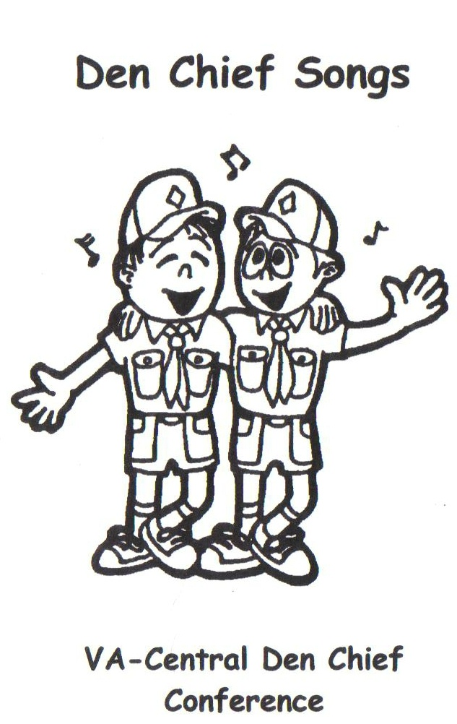

If you can’t sing . . . Chant!

We tell leaders these simple rules: If you can’t sing well, sing loud. And if you can’t sing at all, chant!

Chants come in two basic varieties—chants everybody says together, and repeat-after-me chants. Chants you say together have common actions. In repeat-after-me, the audience echoes the leaders words and actions. Repeat-after-me has the advantage of the audience not knowing the words before hand; it is easy to adapt to special situations—holidays, outdoors, indoors …

In either case, all you need to remember are the words and the beat. You can get the audience to follow the beat by setting up a counting sequence (like in the Beaver Chant) or alternately clapping/slapping your knees. By setting the pace, you can vary the chant by speeding up to “Cub Scout Speed,” “Super Cub Speed,” etc.

Repeat-after-me chants often begin by the leader simply starting the pace—clap, slap, clap, slap. Some in the audience immediately get it and join in; soon everyone will be clapping. You can also start or add on the first lines:

Leader says: This is a repeat after me song (or chant)
Audience echoes: This is a repeat after me song (or chant)

Whatever you do, have fun!

Beaver Chant

Beaver one, beaver all, let’s all do the beaver call
(Make a toothy beaver face, paws up, to the count of – 123, 123, 1234, 123)
Beaver two, beaver three, let’s all climb the beaver tree
(Beaver face, climbing motion to the count)
Beaver four, beaver five, let’s all do the beaver dive
(Beaver face, diving motion to the count)
Beaver six, beaver seven, let’s all go to beaver heaven
(Beaver face, folded hands to the count)
Beaver eight, beaver nine, Stop! It’s beaver time.
(Ditty bop to the count twice)

Elephant Chant

To start: Form a line of three elephants. Lead elephant swings his/her “trunk”. End elephant swings his tail. Middle elephants grab around the waist. Elephants move in a circle.

Chant:
Three little elephants came to play
On a spider’s web one day
They found it such tremendous fun
That they all called another elephant to come.
(Stamp, stamp, stamp)

Each elephant gets another elephant to join the line. Next verse starts: Six little elephants …. Then, twelve little elephants, until everyone is in line.

Flea-ska
The original repeat after me

In this song, the song leader sings (says) a line and the audience repeats the line. Keep the beat by alternately slapping thighs and clapping hands.

Flea!
Flea Fly!
Flea Fly Flo!
Flea-ska (or vista)
Coo-ma-la, Coo-ma-la, Coo-ma-la flea-ska (or vista)
Oh no-no, no, not the flea-ska
Eenie, meenie, decimeenie, oo walla walla meenie!
Ex a meenie, zoll a meenie, oo walla wall!
Bee billy ott in dotten oh bo ba beaten dotten shh!

Other Versions and Variations

Flea!
Flea Fly!
Flea Fly Mosquito!
Oh no no no no Mosquito!
Get that big bad bug with the bug spray!
PSSSSSSSSSSH (spray can sound)

Repeat three or more times, each time a little faster.

Fleas (audience repeats)
Fleas Flies (audience repeats)
Fleas Flies Mosquitos (audience repeats)
Calamine, calamine, calamine lotion
Oh no, no more calamine lotion
Itsy bitsy, teeny weenie, Nasty bitey mosquito
SQUASH (squash is yelled at top of lungs)

Froggie

Dog
Dog - Cat
Dog - Cat - Mouse
Froggie!
Itsy Bitsy teeny weenie little greenie froggie
Jump, jump, jump little froggie
Little greenie froggie eating all the bugs and spiders
Fleas and flies are scrumpditllyitious
Ribit ribit ribit ribit ribit ribit CROAK !

FASTER ! (speed up the tempo)
CUB SCOUT SPEED !! (speed up the tempo)
SUPER CUB SCOUT SPEED !!!! (Here’s the tricky one)
Dog croak ! (one slap "Dog", One clap "Croak")
After a few times the audience will get SUPER CUB SCOUT SPEED
You can have even more fun with Froggie (or any chant) by adding hand motions to the words. For example,
Dog hands at side of head curled down like dog ears
Cat hands at side of head pointed up like cat ears
Mouse two fingers each hand extended under nose like mouse whiskers
Spiders & Flies climbing spider hands, flying fly hands
Scrumpdillyishus frog tongue sticking out & lip licking
Jumping froggie jump like a froggie
Pizza!

Sauce
Sauce and cheese
Sauce and cheese and anchovies
Pizza!
Eat-a-lotta, eat-a-lotta, eat-a lotta pizza
Oh, no! Don't drop the pizza!
If you drop the pizza then you won’t eatsa
Pizza and Coke are srump-dili-icious
Gobble, gobble, gobble, gobble, gobble, gobble BURP!

Creepy Crawlie Rap

Snakes
Snakes are
Snakes are gross!
Creepy!
Creepy creepy creepy crawlie, there’s another, oh my golly!
Ooh what a drag there’s one inside my sleeping bag.

Skunks
Skunks smell
Skunks smell bad.
Stinky!
The only thing worse is a pair of your dirty socks.
Ooh says your mom when you take off your tennis shoes.

Fleas
Fleas fly
Fleas fly slow.
Itchy!
Itchy, itchy, scratchy, scratchy, there’s another on my back-ie
Ee-eek go the bugs when you hit them with the bug spray!
PSSSSST! (Thumb up like on top of a spray can.)

Boom Chick-a-Boom

I said a-boom [Audience echoes]
I said a-boom-chick-a-boom! [Audience echoes]
I said a-boom [Audience echoes]
I said a-boom-chick-a-boom! [Audience echoes]
I said a-boom-chick-a-rock-a-chick-a-rock-a-chick-a-boom! [Audience echoes]

Uh-huh! [Group echoes.]
On Yeah! [Group echoes.]
This time! [Group echoes.]
We sing! [Group echoes.]
HIGHER!

Each time a leader adds a different variation such as: LOWER, WHISPER, LOUDER, TONGUE-IN-CHEEK, GROOVY (COOL).

Cub Scout Cheer
To the “tune” of Boom-Chick-a-Boom

I said search Tiger search
I said search Tiger search
I said search discover share, discover share, discover search
Ah ha! Oh, yeah! Meow

I said Wolf learn the Law
I said Wolf learn the Law
I said Wolf Law of the Pack, Law of the Pack, learn the Law
Ah ha! Oh, yeah! A-woo

I said Bear do it Bear
I said Bear do it Bear
I said Bear follow the trail, follow the trail, do your best
Ah ha! Oh, yeah! Grrrrr

I said go Webelos go
I said go Webelos go
I said go Arrow of Light, Arrow of Light, Webelos go
Ah ha! Oh, yeah! Be Loyal

I said Scout be a Scout
I said Scout be a Scout
I said Scout do a good turn, do a good turn, be a Scout
Ah ha! Oh, yeah! Prepared

I said learn Leader learn
I said learn Leader learn
I said learn go to training, go to training, go to learn
Ah ha! Oh, yeah! I'm Trained

Charles Monts, Pack 1530, Powhatan District, National Capital Area Council, 1998 Pow Wow

Tarzan
Another repeat-after-me

Tarzan!
Swinging from a rubber band
Crashed into a frying pan
Now Tarzan has a tan

Jane!
Was flying in an aeroplane
Crashed into a freeway lane
Now Jane's got a pain
Now Tarzan's got a tan

Cheetah!
Was walking down the street-a
Moving to the beat-a
Now Cheetah is Velveeta
Now Jane's got a pain
Now Tarzan's got a tan

Shamu!
Was swimming in the ocean blue
Crashed into a big canoe
Now Shamu's gonna sue
Now Cheetah is Velveeta
Now Jane's got a pain
Now Tarzan's got a tan

Charlie!
Was riding on his Harley
Crashed into Bob Marley
Now Charlie's not so gnarly
Now Shamu's gonna sue
Now Cheetah is Velveeta
Now Jane's got a pain
Now Tarzan's got a tan
Now my friends that is the end.

-- Katrina Paruch, Brownie leader, British Columbia, Canada

Little Red Wagon

You can't ride in my little red wagon
Backseat's broken and the axle is draggin’
You can't ride in my little red wagon
Maybe tomorrow, but NO NOT TODAY!

Second verse, same as the first,
A whole lot louder and a whole lot worse. etc.

After about four or five verses, no words can be made out in the din that results.

-- Nathan Beauheim, 1997 Scoutcraft Director, Camp Frank Rand Chimayo, NM, Great SW Council

The Black Socks Suite
Black Socks

Blacks socks, they never get dirty,
The longer you wear them the cleaner they get.
Some day, I probably will wash them,
But something keeps telling me
Don’t do it yet, not yet, not yet, not yet........

White socks, they always get dirty,
The longer you wear them the grayer they get.
Some day, I probably will wash them,
But something keeps telling me
Don’t do it yet, not yet, not yet, not yet........

The original song/chant comes from the Girl Scouts. There are many variations, shown below.

Variations
Scout Socks

Scout socks, they never get dirty,
The longer you wear them the cleaner they get.
Some day, I probably will wash them,
But something keeps telling me
Don’t do it yet, not yet, not yet, not yet........
Green Socks

Green socks they never get dirty
The longer you wear them the stronger they get.
Sometimes I think I might wash them
But something inside me keeps saying
Not Yet Not Yet Not Yet NOT YET!!!!

The Camp Shirts Chant

Camp Shirts, they never get dirty...
They longer you wear them the stronger you get...
Sometimes I think we should wash them,
But something inside me keeps saying
Don’t do it yet, not yet, not yet, not yet …

Peanut, Peanut Butter, Jelly

Peanut, peanut butter (and Jelly)
Peanut, peanut butter (and Jelly)

First you take the peanuts
And you dig 'em,
And you dig 'em,
And you dig 'em, dig 'em, dig 'em,
Then you smash 'em, smash 'em,
Smash 'em.
Then you spread 'em, and you spread 'em,
And you spread 'em, spread 'em,
Spread 'em.

Peanut, peanut butter (Jelly)
Peanut, peanut butter (Jelly)
Next you take the berries
And you pick 'em, and you pick 'em,
And you pick 'em, pick 'em,
Pick 'em.
And you smash 'em, smash 'em,
Smash 'em.
And you spread 'em, and you spread 'em,
And you spread 'em, spread 'em,
Spread 'em.

Peanut, peanut butter (Jelly)
Peanut, peanut butter (Jelly)
Then you take the sandwich
And you bite it, and you bite it,
And you bite it, bite it, bite it.
And you chew it, and you chew it,
And you chew it, chew it, chew it.
And you swallow, and you swallow,
And you swallow, swallow, swallow.

MM-MM, MM-MM MM-MM
MM-MM, MM-MM MM-MM.

Salt and Pepper

My name is salt (clap clap clap clap)
My name is pepper (clap clap clap clap)
I taste real good (clap clap clap clap)
I taste like pepper (clap clap clap clap)
When salt goes away (clap clap clap clap)
Pepper starts to cry—wa wa wa wa
When salt comes back (clap clap clap clap)
We are together!

A-Root-Chy-Cha

Hands up! (they echo & do motion)
Wrists together! (they echo & do motion)

A-root-chy-cha, a-root-chy-cha, a-root-chy-cha CHA!
A-root-chy-cha, a-root-chy-cha, a-root-chy-cha CHA!

Hands Up! (echo)
Wrists together! (echo)
Elbows In! (echo) (keep adding the motion)

A-root-chy-cha, a-root-chy-cha, a-root-chy-cha CHA!
A-root-chy-cha, a-root-chy-cha, a-root-chy-cha CHA!

Hands Up! (echo)
Wrists together! (echo)
Elbows In! (echo)
Head back! (echo)

A-root-chy-cha, a-root-chy-cha, a-root-chy-cha CHA!
A-root-chy-cha, a-root-chy-cha, a-root-chy-cha CHA!

Keep going back to the beginning, adding one motion each time and doing the "root-chy-cha" chorus. During the chorus, kids are moving to the beat.

Add:
Knees together....
Toes together....
Bottom out....
Eyes closed....
Tongue out.....
MORE SONGS!

WE’RE GLAD TO SEE YOU HERE
(tune: “Farmer in the Dell”)

We’re glad to see you hear,
It gives us joy and cheer,
Sure, it’s true, we say to you,
We’re glad to see you here!

IT’S A CUB SCOUT WORLD
(tune: “It’s a Small World”)

There’s a world of scouting, a world of fun,
There’s a world of sharing for ev’ryone,
From Tibet to Peru,
Mozambique, Timbuktu,
It’s a Cub’s world after all!

CHORUS

It’s a Cub Scout’s promise to help and care,
In our homes, our country, and ev’rywhere,
From Brazil, Turkey, Spain,
Liechtenstein, the Ukraine,
It’s a Cub’s world after all!

CHORUS

Though Cubs may be diff’rent around the earth,
By the Cub Scout Promise they prove their worth,
From Bhutan to Japan,
Pakistan, Newfoundland,
It’s a Cub’s world after all!

CHORUS:

It’s a Cub’s world after all,
It’s a Cub’s world after all,
It’s a Cub’s world after all,
It’s a Cub Scout world!

THE BACKWARDS SONG

Have the Cub Scouts sing a short song.
Then announce that they will sing it backwards.
The Cub Scouts turn their backs to the audience and sing the song again.

CUB SCOUT FUN!
(tune: “Jingle Bells”)

Dashing down the street,
My Den Leader’s house is near,
Lots of friends to meet,
Scouting fun and cheer!

We’ll earn our whittlin’ chip,
Then tie our knots real tight,
To have some fun now here’s a tip,
Den meeting is tonight! Oh,

CHORUS

Always do your best,
Is the motto of a scout,
Meeting ev’ry test,
Helping others out.

We earn our Bobcat rank,
Then Tiger, Wolf and Bear,
For Webelos we give our thanks,
For Boy Scouts we’re prepared! Oh,

CHORUS:

Cub Scout fun! Cub Scout fun!
Cub Scouts all the way!
Come and see what we’re about,
We hope that you will sta-ay!
Cub Scout fun! Cub Scout fun!
Cub Scouts all the way!
Come and see what we’re about,
We hope that you will sta-ay!

TIGER CUBS, WE SING THIS SONG
(tune: “Camptown Races”)

Tiger Cubs we sing this song, do-dah, do-dah,
Tiger outings all year long, oh, do-dah-day!
Search, Discover, Share,
Tiger Cubs are there!
Betcha Tigers have a lot of fun,
Like Webelos, Wolves, and Bears!

THE BANQUET THAT’S BALOO AND GOLD
(tune: “The Caissons go Rolling Along”)

Over here, over there,
As we trail the Scouting Bear,
To the banquet that’s Baloo and Gold!

Tiger Cubs, Wolves and Bears,
Webelos will all be there,
At the banquet that’s Baloo and Gold!

CHORUS

It’s Baloo we must thank
As we earn our badge of rank
At the banquet that’s Baloo and Gold!
Boy Scouts now, what a sight!
Crossed the bridge this special night
At the banquet that’s Baloo and Gold!

CHORUS:

If you love Cub Scouts
Join Baloo in cheers and shouts,
Yell out our motto loud and bold! (shouted: Do Your Best!)
If we do our best
We can join the rest
At the Banquet that’s Baloo and Gold! Yeah!

MULES
(tune: “Auld Lang Syne”)

On mules we find two legs behind
And two we find before.
We stand behind before we find
What the two behind are for.

When we’re behind the two behind
We find what these be for.
So stand behind the two behind
And behind the two before.

CUBS, CUBS!
(tune: “Hail, Hail, the Gang’s all Here”)

Cubs, Cubs, We’re friendly Cubs,
We all work together,
In fair or stormy weather!
Cubs, Cubs, we’re busy Cubs,
Helping hands and happy hearts!
Fun, fun, we all have fun,
Camping, cook-outs, races,
Give us smiling faces!
Fun, fun, it sure is fun
Making friends and taking part!

DO YOUR EARS HANG LOW?
(tune: “Turkey in the Straw”)

Do your ears hang low?
Do they wobble to and fro?
Can you tie them in a knot?
Can you tie them in a bow?
Can you throw them o’er your shoulder
Like a Continental soldier?
Do your ears__hang__low?

ONE FINGER, ONE THUMB

One finger, one thumb, one hand, one arm, keep moving.
One finger, one thumb, one hand, one arm, keep moving.
One finger, one thumb, one hand, one arm, keep moving.
One finger, one thumb, one hand, one arm, keep moving.
And we’ll all be happy again, HEY!

(in time to music, touch finger, thumb, hand, then move one arm. For next verse, add
“two arms,” then “one leg,” “two legs,” “stand up,” “sit down,” “turn around”)

THE ANTS GO MARCHING
(tune: “When Johnny Comes Marching Home Again”)

The ants go marching
One by one,
Hurrah, hurrah!
The ants go marching
One by one,
Hurrah, hurrah!

The ants go marching
One by one,
The little one stopped to
Shoot his gun,
And they all go marching down...
Into the ground...
To get out...
Of the rain...
Boom! Boom! Boom!
Boom! Boom! Boom! Boom!

(In succeeding verses, change
“One by one” into “Two by two”
“Three by three,” etc. and use
the following in place of
“Shoot his gun”:

Two – “Tie his shoe”
Three – “Climb a tree”
Four – “Shut the door”
Five – “Take a dive”
Six – “Pick up sticks”
Seven – “Look at heaven”
Eight – “Shut the gate”
Nine – Check the time”
Ten – “Say, ‘The End’”)

CUB SCOUT MARCHING SONG
(tune: “This Old Man”)

This Cub Scout, number one,
He sure likes to get things done!
CHORUS
This Cub Scout, number two,
He will do big jobs for you!
CHORUS
This Cub Scout, number three,
Full of humor, full of glee!
CHORUS
This Cub Scout, number four,
Follows rules and knows the score!
CHORUS
This Cub Scout, number five,
He has courage, he has drive!
CHORUS
This Cub Scout, number six,
He’ll do tricks with ropes and sticks!
CHORUS
This Cub Scout, number sev’n,
Will join the troop at age elev’n!
CHORUS
This Cub Scout, number eight,
He thinks scouting’s really great!
CHORUS
This Cub Scout, number nine,
He’s so pleasant all the time!
CHORUS
This Cub Scout, number ten,
Sings the chorus once again!

CHORUS:

With a nick-knack-paddy-wack
Give a Cub a chore,
This he’ll do and ask for more!

THE GRAND OLD DUKE OF YORK
(tune: “A-Hunting We Will Go”)

The Grand Old Duke of York,
He had ten thousand men,
He marched them the hill
(everyone stands up)
And he marched them down again.
(everyone sits down)
And when you’re up you’re up,
(everyone stands up)
And when you’re down you’re down,
(everyone sits down)
And when you’re only halfway up,
(everyone stands halfway up)
You’re neither up nor down!
(everyone stands up and sits down quickly)
(repeat several times, getting faster each time)

CALL A SCOUT
(tune: “If You’re Happy and You Know It”)

When you’re down and feeling blue
Call a Scout!
They will know just what to do
Call a Scout!
If you’re ever in a hurry
And you really start to worry
All you have to do is shout,
Call a Scout!

If you need a helping hand
Call a Scout!
They’ll take your garbage out,
Call a Scout!
If the traffic that you’ll meet
Has you scared to cross the street
They’ll be there to help you out –
Call a Scout!

Now the Scouts are always helpful,
Don’t you see?
They will lend a helping hand
To you and me!
For they’re wise in what they do,
They are kind and cheerful too,
And they always help you out –
Call a Scout!

O LORD IT’S GREAT TO BE WOLF CUBS
(tune: “O Lord, It’s Hard to be Humble”)

O Lord, it’s great to be Wolf Cubs,
Our pack’s getting better each da-y,
Earning our beads and our badges,
With the Old Wolves to show us the way;
You may think that we are just bragging,
We’ll be the best Boy Scouts some da-y,
O Lord, it’s great to be Wolf Cubs,
Doing our best ev’ry day!

O Lord, it’s great to be Wolf Cubs,
Doing good turns ev-e-ry da-y,
Keeping the Law and the Promise,
As we work and we sing and we play;
There’s meetings and outings and camping,
And friends who we meet on the wa-y,
O Lord, it’s great to be Wolf Cubs,
Doing our best ev’ry day!

So let’s give a cheer for the Wolf Cubs,
Let’s hear it, hip, hip, hoo-ra-y!
O Lord, it’s great to be Wolf Cubs,
Doing our best ev-e-ry da-y,
So tell us, just what are we doing?
We’re…….
Doing our best ev’ry day!

I’VE BEEN WORKIN’ IN MY SCOUT DEN
(tune: “I’ve been Workin’ on the Railroad”)

I’ve been workin’ in my scout den
Building out of wood,
I’ve been workin’ in my scout den
Like any Cub Scout should.

Can’t you see what I am building,
Book ends with matching picture frame?
Can’t you hear what Mom is saying,
House won’t be the same! Oh,

Hammer, hammer, saw,
Hammer, hammer, saw,
Hammer, hammer, saw, saw, sa-a-w,
Hammer, hammer, saw,
Hammer, hammer, saw,
Hammer, hammer, hammer, saw!

Someone’s in the workshop with Cub Scouts,
Someone’s in the workshop I kno-o-o-ow,
Someone’s in the workshop with Cub Scouts,
Leader says it’s time to go! Oh,

Hammer, hammer, saw,
Hammer, hammer, saw,
Hammer, hammer, saw, saw, sa-a-w,
Hammer, hammer, saw,
Hammer, hammer, saw,
Hammer, hammer, hammer, saw!

RAVIOLI
(tune: “Alouette”)

All: Ravioli, I like ravioli.
Ravioli, it’s the best for me!
Leader: Have I got it on my chin?
All: Yes, you’ve got it on your chin!
Leader: On my chin?
All: On your chin! Oh-h-h-h-h,
Ravioli, I like ravioli.
Ravioli, it’s the best for me!
2nd verse: tie
3rd verse: shirt
4th verse: pants
5th verse: shoes
6th verse: floor
7th verse: walls
8th verse, Leader: All o-ver?
All: Yes, all over!
Leader: It’s all over?
All: Yes, it’s over!

TAPS

Day is done, gone the sun,
From the lakes,
From the hills,
From the skies.
All is well, safely rest,
God is nigh.

Fading light, dims the sight,
And the stars
Gem the skies,
Gleaming bright.
From afar, drawing nigh,
Falls the light.

Then goodnight, peaceful night,
Till the light
Of the dawn
Shineth bright.
God is near, do not fear,
Friend, goodnight.

CUB SCOUT TAPS

Sun of gold, sky of blue,
Both are gone
From our sight,
Day is through.
Do your best, then to rest,
Peace to you.

CUB SCOUT VESPERS
(tune: “O Tannenbaum”)

As the night comes to this land,
On my promise I will stand.
I will help the pack to go,
As our pack helps me to grow.
I will always give goodwill,
Following Akela still.
And before I stop to rest,
I will do my very best.

SCOUT VESPER SONG
(tune: “O Tannenbaum”)

Softly falls the light of day,
While the campfire fades away.
Silently each scout should ask,
Have I done my daily task?
Have I kept my honor bright?
Can I guiltless sleep tonight?
Have I done and have I dared
Everything to be prepared?

SCOUT WETSPERS
(tune: “O Tannenbaum”)

Softly falls the rain today
As our campsite floats away.
Silently, each Scout should ask,
Did I bring my scuba mask?
Have I tied my tent flaps down?
Learned to swim, so I won't drown?
Have I done, and will I try
Everything to keep me dry?"

SKITS AND WALK-ONS

Skits have a number of purposes:

- Build teamwork and den spirit
- Give everyone a chance to take part, be a “star”
- Build self-confidence and leadership
- Boost den and pack morale and good cheer
- Remind scouts about promise/law, scouting values/responsibilities

Select skit to suit the occasion:
- Funny skits – easier to do, mistakes can add to the silliness. Must be appropriate and in good taste! In doubt? Ask your Den Leader.

- Serious skits – rehearsal is important. Usually emphasize patriotism, love of country or importance of scouting values. Must be appropriate for the occasion to be meaningful. Work with your Den Leader and Cubmaster.

Props: necessary for many skits. Flags, candles, lights, emblems, signs, costumes, den doodles, even music! Use your imagination!

Good Skits:
- In good taste
- Of reasonable length
- Well planned and rehearsed
- Well-staged, good spirit
- Scouts speak loud enough to be heard!

Resources:
- Roundtable handouts
- Internet – Big Book of Skits (www.macscouter.com/skits)

Why Skits?
Entertainment
Theater is one of oldest art forms (Theater Merit Badge)
Fantasy
Do things “not permitted”
Instant Recognition
The “flow” of having done a great job

Skit Considerations
Appropriate vs. Inappropriate
Officially
Violate Youth Protection Training
Violate Safe Guide to Scouting
Avoid topics that lack Good Judgement
Racism, Divorce, Love Stories, Sexuality, Profanity, Unpatriotic themes, Gruesomeness, Disrespect, Physical Disabilities
* As a general rule, if it degrades a specific person or group of people, do not use it. If you are in doubt as to how the theme will be received, discard it.

Props and Scenery
Cubs enjoy creating things used in a skit
Can assist in the completion of achievements, electives and Webelos activities
See the Cub Scout Leader’s How-To Book for ideas on scenery, masks and costumes
(Flame retardant materials)

Age of participants

Can the skit work with minor improvisations?

Timing of the skit

Serious vs. goofy skits at somber moments and vice versus

Setting; Indoor vs. Outdoor
Use of microphone- especially at campfires

Long vs. Short
Walk-ons
One liners

Clean Humor vs. ___________
Obscene
Violence << Really used excessively

“Victim” selection
Unknowing – good sport
Secret partner

Practice
Lots vs. some vs. none
Improvise

Audience
Age
Scouts vs. non-Scouts

Cub humor is not adult humor

RESOURCES
http://www.macscouter.com/Skits/ <<< Real good
http://members.iinet.net.au/~oneilg/scouts/songs/skityells.html
http://web.archive.org/web/20010619091922/www.usol.com/~shsims/skits.htm
http://web.archive.org/web/20010526151136/www.norfolkscouts.org.uk/res/ledow/stunts10.html
http://www.scoutorama.com/skit/sk_results.cfm <<< Real good
http://www.powwow-online.net/pizzazz/skits/index.htm
GROUP MEETING SPARKLERS WW33122A $2.00

CUB SCOUT LEADER’S HOW-TO BOOK
CUB SCOUT MAGIC BOOK

ENLARGING MACHINE
A person plays the role of a great inventor who has created an enlarging machine. The "machine" could be a large box with somebody inside, or else a blanket or something similar held up with a person out of sight behind it. The inventor expounds at length about what a wonderful invention his machine is, and demonstrates by enlarging several objects. Some examples may be a pebble dropped in and a large rock flies back out, a small twig and a large piece of wood, a face flannel and a towel. Just use your imagination.
There are two main variations for the punch line.
- A heckler says he thinks the machine is rubbish, and says "This is what I think of your machine" as he spits into it - he then gets drenched by a bucket of water. A variation is to have someone standing beside the machine "accidentally" spill a drink and have the bucket of water thrown back out.
- A "mother" with a "baby" (doll) is looking at the machine and the baby falls in. She gets chased off by an adult dressed as a baby and calling out "Mummy..."

IS IT TIME YET?
A number of people are sitting in a row, right leg crossed over left and reading newspapers. The person at the end asks the person next to him "Is it time yet?" The person asked turns to the person on their other side and asks the same question, and the question gets passed from person to person along the line until it reaches the other end. The person at the end looks at their watch, says "Not yet" and it gets passed back along the line.
Everyone sits reading for a while longer, then the first person asks again "Is it time yet?" Once again the message is passed along the line, and the reply is again "Not yet".
After another wait the question is asked again. This time the person at the other end looks at their watch and says "Yes, it's time." When this message reaches the other end of the line, everyone crosses their legs the other way so their left leg is over the right and continues reading...

PUPPY IN THE BOX
Need: 5 scouts (1 as announcer) Props: A cardboard box, and a stuffed dog (or rabbit, etc.)
Announcer: This scene takes place on the street outside a grocery store.
(Several participants are gathered around outside the store, chatting.)
Scout 1: (Enters holding the box) Hi guys, would you please hold this box for me while I go into the store? (Exits)
Scout 2: I wonder what's in the box?
Scout 3: I don't know, but something is leaking out!
Scout 4: (Rubs finger against the bottom of box, then licks finger) Hmmm, it tastes like lemon soda.
Scout 3: (Also rubs box and tastes finger) No. I think it's more like chicken soup.
Scout 1: (Returns, looks in box and pulls out stuffed dog) Oh, you naughty puppy!

DIRTY SOCKS
Need: 4 scouts, One large can (Billy can or gallon can) with water placed in the center of the stage.
1st scout (Walks to billy carrying his mug. He dips his mug in and brings it up to his lips for a drink.) "HIS CAMP COFFEE IS GETTING WORSE! "
2nd scout (Walks to billy carrying his mug. He dips his mug in and brings it up to his lips for a drink.)
"HIS CAMP TEA IS GETTING WORSE! "
3rd scout (Walks to billy carrying his mug. He dips his mug in and brings it up to his lips for a drink.) "THIS CAMP CHOCOLATE IS GETTING WORSE! "
4th scout (Walks to billy, dips his hands in and takes out a pair of wet socks. As he wrings them out he says.) "I THOUGHT THAT WOULD GET THEM CLEAN!"

A COMPASS LESSON
Need: 1 leader and 2 or more scouts. Props: A good compass and a map
Announcer: In this scene, we see a Scoutmaster teaching a Patrol about maps and compass.
Scoutmaster: Now fellows, if you take a bearing from the map this way you can now stand up and, keeping the compass away from your belt buckle, walk along the bearing until you reach your destination. John, you try that.
John: (Does as instructed, exits, re-enters)
Scoutmaster: (Standing) In the same way you can take a bearing on a distant object, and use that to find where you are on the map. Now, each of you take a bearing on that big tree on the hill top.
Other boys: (Do as instructed, passing compass around, making suitable comments.)
Scoutmaster: (After a few moments) All right, let's all gather around. That wraps up tonight's compass lesson. There is just one more important point ! Never, never buy a TATES compass.
Tom: Scouter, why should we never buy a TATES compass ?
Scoutmaster: You know the old saying: "He who has a TATES is lost!"

THE RAISIN
Need: 5 Scouts (1 to be a table).
1st Scout comes out: Gets down on all fours, pretending to be a table.
2nd Scout comes out, looks at the table and declares;
2nd SCOUT: "Ahh, a fly, I think I'll pull its wings off" Proceeds to pick it up, pluck the wings, put it back on the table, and walks off.
3nd Scout comes out, looks at the fly on the table and says;
3rd SCOUT: "Oh, a fly with no wings, I think I'll pull it's legs off", With great precision and animation, picks up the fly, removes it's legs, and puts it back and walks off.
4rd Scout comes out, looks at the fly and announces;
4th SCOUT: "Say, a fly with no wings and no legs, I think I'll pull it's head off." Then proceeds as the other Scout before him.
Last Scout comes out looks at the table, then carefully inspects the object with out picking it up and says very quickly
LAST SCOUT: "A raisin!" and quickly picks it up and puts it in his mouth

WORLDS GREATEST SPITTER
(Separate SPITTER and partner by about 15 feet.)
Partner: Ladies and Gentlemen! May I present to you the Greatest Spitter in the World! He does all kinds of tricks with a mere spit! Let him show you the simple spit first!
(SPITTER sends off a regular spit, which is caught in the pot by the partner. When it's supposed to land, he hits the bottom of the pot with a secret pebble he holds in his hand.)
Partner: Ladies and Gents! That is not all he can do! Watch his fastball!
(SPITTER, again sends another spit which immediately "lands" in the pot. Continue with tricks, such as slow spit, high spit, round the world spit (in which case each turns around, backs facing each other, and the spit takes a while to come around but indeed does,) curve spit, and so on. Finally,)
Partner: Now for his last spit! It's a really difficult spit but we think we have it! It's a high, quadruple axle, curvy, spring jump spit! We must have absolute silence for this one!
(SPITTER spits up, partner follows it up, doing 4 spins, it curves side to side, begins to jump up and down in air, then he seems to lose it ... no, there it is ... he goes side to side, trying to catch it, he trips and spills the water on the crowd.)

THE FORTUNE TELLER
This is a campfire skit. You can plan it carefully if you want. If you have a good spontaneous actor, he might be able to ad-lib responses to each object presented to him, without advance planning. The Announcer should always tell the audience what object is given to the Fortune Teller, because they usually will not be able to see clearly.

The Skit
A small tent is set up, with an old lady sitting in front of it. This can be a Scout wrapped up in a blanket, who speaks with an old lady's voice.
An Announcer introduces her as a very accurate teller of fortunes who can predict a person's future by touching anything belonging to the person.
The Announcer calls up a series of Scouts. He asks the first Scout what he has brought, and the Scout produces a pencil. The Announcer hands the pencil to the Fortune Teller and asks her to tell the future of the owner. The Fortune Teller waves her hands and mumbles some words and then predicts that the owner will become a writer.
The scene is repeated. A Scout produces a comb from his pocket, and the Fortune Teller predicts that he will become a hairdresser.
A third Scout has a dollar, and she predicts that he will become a successful banker.
After several of these, the Scapegoat is summoned from the audience. The announcer asks what he has to show the Fortune Teller. No matter what the Scapegoat suggests, the Announcer says it is not good enough. Either it has been done before, or it is too easy, or "That's no fun!", or any other reason. Finally, the Announcer suggests that the Scapegoat try his shoe, and makes him take it off. The shoe is handed to the Fortuneteller, who repeats her mumbo jumbo. (If the Fortune Teller is a good pantomime, this is a wonderful opportunity to make faces, hold her nose, etc.) She then announces, "You will take a long walk in the woods!" She throws the shoe far into the woods.

ALIBABA
ALIBABA (standing tall and strong)
SERVANT (approaches excitedly): ALIBABA, ALIBABA, how can I become as tall and strong as you are?
ALIBABA (rubbing chin): Hmmm, let me think...OK..go rub oil over your entire body every day for two weeks.
SERVANT: OK (walks off stage)
SERVANT (walks on stage crouched down bending knees): ALIBABA, ALIBABA..it didn't work...now I'm even shorter.
ALIBABA: Hmmm....let me think...go rub oil over your entire body for four weeks.
SERVANT: OK (walks off stage)
SERVANT (walks on stage crouched all the way down to floor-ankle level): ALIBABA, ALIBABA...now I am even shorter.
ALIBABA (rubbing chin): Hmmm....did you rub oil all over your entire body for four weeks?
SERVANT: Yes
ALIBABA: Hmmm...what kind of oil did you use?
SERVANT: Crisco
ALIBABA: Crisco? That's not oil! That's shortening!!!

SPRINGTIME IN VERMONT
Scout: I am making a painting. I first need a tree. (He picks a scout and places him like a tree.) Now I need a stick. (He takes another scout and lays him on the ground arms at his side.) Now I need a bear. He takes another scout and places him like he is attacking the tree.) Now I need a hiker. (He takes another scout and places him like a hiker.) Now I need a frame. (He takes audience member and makes him run around the scouts.) Now I need a title, Aha! Springtime in Vermont...and the Sap is Running!

WAITER, THERE IS A FLY IN MY ________
Customer 1: Waiter! There's a fly in my soup!
Waiter: Shh! Everyone else will want one!
Same line continues on with other customers about a fly being in:
Customer: Alphabet soup
Waiter: He's learning to read!
Customer: What's this fly doing in my soup?
Waiter: The backstroke, Sir!
Customer: There's a fly in my soup!
Waiter: Pass him a life preserver!
Customer: I just took a fly out of my soup. What do you think you should do?
Waiter: Give First Aid!
Last Customer: Waiter, did you know that there's a fly in my ice cream, too?
Waiter: No! I didn't know they were into winter sports!

THE INFANTRY IS COMING!
3-4 People, Person carrying a sapling
#1: (Runs in) The Infantry is coming! Go to the bomb shelters!
#2: (A moment later, runs in) The Infantry is coming! Save yourselves!
#3: (A moment later, runs in) The Infantry is coming! Let's help them!
#4: (A moment later, runs in) The Infantry is coming! Let's watch the tanks!
(A moment later)
Person: And here it is, the Infant Tree.

BAD BREATH
One blanket-covered player is the terrible dragon with the terrible breath. Plant three or four "volunteers" in the audience who come up, one by one, to say hello to the dragon. Each time the dragon replies, "Hello!", the "volunteer" falls over dead (lots of scope for hams, here). Then, ask for a real volunteer to say hello to the dragon. When he says, "Hello, Dragon", the dragon falls over dead.

CHANGE UNDERWEAR
Have the boys hike in, single file, with the “Cubmaster” following. The “Cubmaster” tells them to stop and addresses them. He tells them he has some good news and some bad news. The good news is that after days of hiking they get a change of underwear. The boys cheer and he cuts them off. The bad news is that they have to change underwear with one another. The boys groan.

DOCTOR! DOCTOR!
The secret to success with this series of quickies is to keep them moving along. You can have one doctor and different patients, but it may add greater rush and flurry if a different doctor and patient fly in and out for each quickie.
Pat: Doctor! Doctor! I feel like a set of drapes.
Doc: Pull yourself together!
Pat: Doctor! Doctor! Am I going to die?
Doc: That's the last thing you'll do.
Pat: Doctor! Doctor! Everyone keeps ignoring me.
Doc: Next!
Pat: Doctor! Doctor! My back feels like a deck of cards!
Doc: I'll deal with you later.
Pat: Doctor! Doctor! What's wrong with me?
Doc: Have you had this before?
Pat: Yes.
Doc: Well, you've got it again!
Doc: You'll live to be 80.
Pat: I am 80.
Doc: See!
Pat: Doctor! Doctor! I've got insomnia.
Doc: Don't lose any sleep over it!
Pat: Doctor! Doctor! My friend's doctor told him he had appendicitis and, two weeks later, my friend died of heart failure.
Doc: Don't worry. If I tell you you've got appendicitis, you'll die from appendicitis!

WALK-ONS!

Walk-ons are short, funny skits used as a transition or to fill time between parts of a pack meeting or a campfire.

YOU DON’T SAY
Person: (Phone rings, picks it up.) Hello? Yes? You don't say ... You don't say ... You don't say ... You don't say? ... You don't say! ... You don't say. Bye!
Friend: Say, who was on the phone?
Person: He didn't say!

STICKIN’ AROUND WALK-ON
BOY: (Comes on stage with a stick in his hand. He puts the point of the stick down on the floor, picks it up, puts it down in another place.)
CUBMASTER: What are you doing?
BOY: Oh, I’m just stickin’ around.

ALL AROUND ME WALK-ON
BOY: (Runs on stage with his hands grasping his waist. He yells:)
Help! It’s all around me. It’s all around me. Help!
CUBMASTER: What’s all around you?
BOY: My belt!

NIGHT COURT WALK-ONS
(This is a unique skit that involves a series of walk-ons that must be closely arranged with the Campfire Leader. Each walk-on would come perhaps, between songs, BUT NEVER to upstage a skit that is about to, or has just been put on.)
PROPS: Briefcase, flashlight, (O.K. to use as a prop), a small ladder, and a banana peel.

WALK-ON 1:
LAWYER: [enters carrying briefcase]
LEADER: Hey, you with the case! Where do you think you’re going?
LAWYER: [strides in, holding up case] I’m taking my case to court! [strides through and out]

WALK-ON #2: (Later)
LAWYER: [enters with case and flashlight]
LEADER: Alright, where are you going now
LAWYER: [waving flashlight] I'm taking my case to night court! Strides through and out]

WALK-ON #3. (Later)
LAWYER: [enters with case and ladder]
LEADER: It's you again! Where are you going with that ladder?
LAWYER: Now I'm taking my case to a higher court! [strides out]

WALK-ON #4 (Later)
LAWYER: [enters with case and banana peel]
LEADER: [angrily I've had it with you walking through here. Now, this is it! Where are you going?
LAWYER: I'm going to the court of last appeals! [strides out]

WALK-ON #5 (Last time)
LAWYER: [wanders in with no props, looking all around]
LEADER: What's up now What are you looking for
LAWYER: I lost my case. [trudges out]

EMERGENCY TEST
A group of Scouts come out and stand in a line across the stage. One, the announcer, stands in front of them.
Announcer: "This is a test"
All: Hmmmmmmmmmmmmmm (or Beeeeeeeeeeeep)
Announcer: This has been a test of the emergency warning system. This was only a test. If there had been a real emergency we would have said... (Scouts throw hands over heads, yell "Ahhhhhh", and run helter-skelter off stage)

OTHER “GOODIES”
YAPOOCHA; THE LAWNMOWER; SIDEWALK CLIMBING BELT LOOP; CUB SCOUT SOCKS; MYSTERY COUNTING STICKS

MORE SKITS!

THE SIX SHIPS OF SCOUTING
Prepare large cardboard cutouts of six ships, on which have been printed: SCHOLAR-SHIP, FELLOW-SHIP, SPORTSMAN-SHIP, WORKMAN-SHIP, STATESMAN-SHIP, FRIEND-SHIP.

CUBMASTER: Tonight, Den (number) would like to tell you about the six ships of scouting. These are ships that we must help to last forever.

FIRST CUB SCOUT: SCHOLAR-SHIP. This ship is very important on the Sea of Education. On her deck stand such officers as Ambition, Determination, Intelligence, and Application. Her flag bears the symbols of the letter “A” and the plus sign.

SECOND CUB SCOUT: FELLOW-SHIP. This ship stands for good spirit, fine cooperation, and never-failing unity. Its flag flies high – the flag of scouting.

THIRD CUB SCOUT: FRIEND-SHIP. This is the most beautiful ship of all. It is true blue and its flag is golden – since friendship itself is golden.

FOURTH CUB SCOUT: SPORTSMAN-SHIP. This ship stands for all that’s fair. It never veers from its course. Its flag is never at half-mast.

FIFTH CUB SCOUT: WORKMAN-SHIP. This ship’s every line, every part, every mast, represents the best that a person can give. Its flag bears a laurel wreath.

SIXTH CUB SCOUT: STATESMAN-SHIP. This ship represents wise guidance, constant counsel, unselfish interest, and sincere endeavor. Its flag is white for purity.

CUBMASTER: And there you have six strong and sturdy ships to brave the Sea of Life. Three cheers for the scouting ships! Hip-hip-hooray!

LITTLE BUNNY FOO-FOO
NARRATOR: Once upon a time there was a little bunny named Little Bunny Foo-Foo. Little Bunny Foo-Foo liked to hop through the forest, scooping up field mice and bopping them on the head.

LITTLE BUNNY FOO-FOO (as he prances about picking up pretend field mice): Little Bunny Foo-Foo, hopping through the forest, scooping up the field mice and boppin’ ‘em on the head.

NARRATOR: Now suddenly appeared a wizard, and he said,

WIZARD: Little Bunny Foo-Foo, I don’t want to see you scooping up the field mice and boppin’ ‘em on the head. I’ll give you three chances, and if you don’t behave, I’ll turn you into a GOON!

NARRATOR: The next day:

LITTLE BUNNY FOO-FOO: Little Bunny Foo-Foo, hopping through the forest, scooping up the field mice and boppin’ ‘em on the head.

WIZARD: Little Bunny Foo-Foo, I don’t want to see you scooping up the field mice and boppin’ ‘em on the head. I’ll give you two more chances, and if you don’t behave, I’ll turn you into a GOON!”

NARRATOR: The next day:

LITTLE BUNNY FOO-FOO: Little Bunny Foo-Foo, hopping through the forest, scooping up the field mice and boppin’ ‘em on the head.

WIZARD: Little Bunny Foo-Foo, I don’t want to see you scooping up the field mice and boppin’ ‘em on the head. I’ll give you only one more chance, and if you don’t behave,
I’ll turn you into a GOON!”

NARRATOR: The next day:

LITTLE BUNNY FOO-FOO: Little Bunny Foo-Foo, hopping through the forest, scooping up the field mice and boppin’ ‘em on the head.

WIZARD: Little Bunny Foo-Foo, that was your last chance. Since you didn’t obey me, I’m going to turn you into a GOON! (WIZARD waves his wand and says “POOF!” LITTLE BUNNY FOO-FOO, now a goon, runs off-stage grunting like a monster.)

NARRATOR: And the moral of this story is, HARE TODAY, GOON TOMORROW!

THE BANDANA-BANANA MAGIC TRICK
MAGICIAN: Hello, hello, what a wonderful crowd we have today! My first trick will be the Disappearing Bandana Trick. For this trick I'll need a volunteer from the audience.
A (fake) volunteer comes up from the audience.
MAGICIAN: Now don't watch me. (the magician and volunteer face in opposite directions. The magician takes out a bandana or hankerchief).
MAGICIAN: First, of course, you need a bandana. Do you have a bandana?
VOLUNTEER (holding up a banana): Yep.
MAGICIAN (opening his bandana and waving it a bit): First, open up the bandana.
The volunteer obediently peels the banana.
MAGICIAN (carefully folding the bandana): Now fold it.
VOLUNTEER: Ummmm, fold it?
MAGICIAN (slightly irritated): Yes, fold it.
VOLUNTEER (folding the banana): Well, OK…..
MAGICIAN (folding the bandana smaller): And fold it again, and again.
The volunteer folds the banana several times, making mush, and making facial expressions like he's not sure the magician is in possession of his senses.
MAGICIAN (holding his fist out behind him): OK? Now, stuff the bandana into my fist.
VOLUNTEER (stuffing the mushed banana into the magician's fist as the magician turns around and stares in disgust): Fine, have the banana. I'm through with this stupid skit!

The volunteer storms off stage.

WEATHER OR KNOTS
DEN LEADER: It's time for our den meeting! [Scout's name] is our denner tonight. Please give him your attention.

DENNER: OK, we're going to be doing two projects tonight. Which do we want to do first - Weather or Knots?

SCOUT1: Whether or not what? Whether or not we're having a meeting tonight? We ALWAYS have a den meeting on Tuesday nights!

SCOUT2: It's Knots that I want to do!

DENNER: Well, if you don't want to do these two projects, what DO you want to do?

SCOUT3: Let's do Weather. It's fair right now.

SCOUT4: What's FAIR about doing weather? I want to do knots!

SCOUT5: What!? We're going to the FAIR? We can't - it's too late. They're closed now!

SCOUT6: Do you know hurricanes have wind speeds of more than 70 knots?

SCOUT7: Seventy knots! I can’t even tie one!

SCOUT4: That's IT! I just tied a bowline!

SCOUT3: We're going BOWLING? Who decided that?

SCOUT6: What's a squall line?

SCOUT2: It's a type of knot - haven't you ever heard of a squall line hitch?

SCOUT5: Are you sure it's not going to rain?

SCOUT7: I hope not. I hate rain. You can't do anything when it rains.

SCOUT4: Can't do anything with REINS? Of course you can! How else do you tie your horse up to the hitching post? I'd use a COW or RING hitch.

SCOUT3: COWERING! What are you afraid of? The weather's nothing to be afraid of!

DENNER: Wait a minute! Could I have you attention, please! All I'm trying to find out is whether we want to do knots!

SCOUT1: Whether we do WHAT?

DENNER: Do knots...

SCOUT3: Or do weather?

SCOUT2: Whether we do WHAT?

SCOUT7: KNOTS!

DENNER: Well NUTS to you too! I just want SOMEDODY to tell me it's WEATHER, or KNOTS!

SCOUT3: It's WEATHER!

DENNER: Whether we do WHAT?

SCOUTS1-7: KNOTS!!!!!!!!

DENNER, running off stage, screaming: AGHHHHHHHHH!

SCOUT1: What's wrong with him?

SCOUT2: I dunno. Leadership must be too much for him.

SCOUT1: What do we want to do next meeting?

SCOUT7: Let's go bowling. That would be fun.

SCOUTS1-6: Sounds good to us!

CLOWNING AROUND
Two clowns, dressed in full clown costumes and with faces painted, are sitting at the front center of the stage, heads on hands.

CLOWN1: I'm bored. There's nothing to do.

Behind the clowns, two Tiger Cubs, wearing Tiger Cub shirts and caps, walk from left to right across the stage. They appear to be talking to each other while they walk.

TIGER1: Boy, bowling with the Tigers next Saturday will be great!

TIGER2: I can't wait!

CLOWN1 suddenly looks up with a smile on his face.

CLOWN1: That's it! We'll go bowling!

Behind the clowns are plastic pins already set up, a plastic bowling ball, a scoresheet on a clipboard, and a pencil. CLOWN1 and CLOWN2 get up, walk over to the "alley," and pick up the bowling ball at the same time. The clowns play tug-of-war with the bowling ball while they argue.

CLOWN2: I'll go first.

CLOWN1: No, I'll go first.

CLOWN2: No, I will.

CLOWN1: No, I will.

As CLOWN2 pulls hard on the bowling ball, CLOWN1 lets go.

CLOWN1: OK, you go first.

CLOWN2 falls backward, holding the ball, into the pins and knocks them over. Offstage, a pile of blocks are knocked over as a sound effect. CLOWN1 picks up the clipboard and pencil.

CLOWN1: Is that a strike or a spare?

Meanwhile, two Tigers (TIGER3 and TIGER4) appear at the left front of the stage. TIGER4 is holding a small box of popcorn.

TIGER3: Cub Scout fundraiser! A dollar a box!

A Tiger parent walks across the front of the stage with a LARGE play-money dollar bill.

PARENT1: I'll buy one!

He hands TIGER3 the dollar bill and takes the box of popcorn from TIGER4.

TIGER4: Thank you for helping out our pack.

TIGER3 looks at the dollar bill.

TIGER3: Hey, we're making BIG money now!

CLOWN2: That's it! We'll sell popcorn!

Behind the clowns is LOTS of popped popcorn in a LARGE paper bag with handles, and two stacks of little bags to dispense the popcorn into. CLOWN1 and CLOWN2 each grabs a handle on the popcorn bag, and each takes a stack of the little bags. They walk together to center-stage.

CLOWN 2: Popcorn! A dollar a bag!

One Tiger parent (PARENT2) comes on stage from the left, and another (PARENT3) comes on stage from the right, at the same time.

PARENTS2&3, in unison: I'll buy one!

While holding the handles of the bag, CLOWN1 walks left to meet PARENT2 and CLOWN2 walks right to meet PARENT3. The bag of popcorn rips in half and all of the popcorn spills out. PARENT2 and PARENT3 shrug their shoulders and walk off.

Now two more Tigers (TIGER5 and TIGER6) walk from right to left across the stage. They appear to be talking to each other.

TIGER5: Wow! The pies at the bake-off last week were great!

TIGER6: My Dad paid twenty dollars for one!

CLOWN1 looks up with a smile on his face.

CLOWN1: That's it! We'll bake a pie!

Behind the clowns is an oven made out of cardboard boxes. On the oven is an egg carton with one hard-boiled egg in it, a flour bag with about a cup of flour in it, a sugar bag with about a cup of sugar in it, an empty pint milk carton, a spoon, and an aluminum pan. A clipboard, with the recipe, is also on the oven. CLOWN2 picks up the clipboard.

CLOWN2 (reading from the recipe): Flour!

CLOWN1 dumps the flour in the pan (raising a cloud!).

CLOWN2: Sugar!

CLOWN1 dumps the sugar in the pan (raising a cloud!).

CLOWN2: Milk!

CLOWN1 slams the milk carton into the pan (raising a cloud!).

CLOWN2: Egg!

CLOWN1 drops the egg into the pan (raising a cloud!). CLOWN1 puts the pan into the oven. The clowns pace back and forth until a bell rings off stage.

CLOWN1&2, in unison: It's done!

The clowns open the oven and take out a pan full of whipped cream, which was in the oven from the start. The tug-of-war begins again.

CLOWN1: I've got it.

CLOWN2: No, I've got it.

CLOWN1: No, I've got it.

CLOWN2: No, I've got it.

As CLOWN1 pulls hard on the pan, CLOWN2 lets go.

CLOWN2: OK, you've got it.

CLOWN1 winds up hitting himself in the face with the pie. CLOWN1 wipes off his face and stamps his foot.

CLOWN1, indignant: That's it. I've had it.

CLOWN1 and CLOWN2 walk to the right front of the stage and face forward.

CLOWN1&2, in unison: We're not clowning around any more! We're joining Tiger Cubs!!

The clowns take Tiger caps out of their pockets, put them on, and give the Cub Scout salute. Offstage:

TIGERS1,2,3,4,5&6, in unison: YEA!!!!!

TIGERS 1,2,3,4,5,6 run to the front of the stage, line up beside the clowns, and also give the Cub Scout salute.

THE STORY OF BLUE AND GOLD
The Blue and Gold Banquet is a good time to reflect on the history of Cub Scouting. The following history could be read in parts by twenty Cub Scouts in your pack. Add props and arrange the scouts in a human time line.

1. This is the story of how Cub Scouts began. It is our story - the story of Blue and Gold.

2. The story of Blue and Gold begins in England in 1907. Older boys are having fun reading a book for soldiers.

3. The book is called, Aids to Scouting. It is written by a man named General Robert Baden-Powell.

4. The book tells the boys how to go camping and live outdoors. General Baden-Powell learns of all the boys reading his book and has an idea.

5. He forms the first Boy Scout Troop at a place called Brownsea Island. The boys go camping, take hikes, and listen to campfire stories.

6. In America, a man named Mr. Ernest Thompson Seton forms a group of boys called the Woodcraft Indians. These boys form tribes, find out about Indian lore, tell stories, and learn nature skills.

7. It is now 1910. The Boy Scouts of America is started by three men. Mr. Seton is one of them. The Woodcraft Indians become a part of the Boy Scouts.

8. The years go by. It’s 1916. Lots of older boys in England and America are having fun in Boy Scouts.

9. Lots of younger boys want to have fun in scouting too. Many parents in England ask General Baden-Powell to help.

10. General Baden-Powell has just read a book called The Jungle Book. It tells the story of a boy raised by a pack of wolves in the jungles of India.

11. General Baden-Powell starts Boy Scouting for younger boys. He gets his ideas from The Jungle Book and calls this scouting, Wolf Cubbing.

12. The years go by. It is now 1929. Lots of younger boys in America want to do Wolf Cubbing. Many parents ask Mr. Seton to help.

13. Mr. Seton starts Cubbing for younger boys. He gets some ideas from Wolf Cubbing in England. He gets other ideas from his Woodcraft Indians.

14. It is now 1930. Cub Scouting begins. Cub Scouting is for boys age 9 through 11. There are five thousand Cub Scouts in America.

15. The years go by. It is now 1933. The country is in the Great Depression, and Cub Scout packs hold their first pot-luck dinners. By 1943, they are called, "Blue and Gold Banquets."

16. The years go by. It is now 1999. Cub Scouts is bigger and better than ever. Cub Scouting is now for boys in first grade through fifth grade. There are now more than 2 million Cub Scouts.

17. We owe much to General Baden-Powell. From his Wolf Cubbing we get cubs, packs, dens, Wolf, Bear, Tiger Cub, Akela, Baloo, and the Law of the Pack.

18. We also owe much to Mr. Seton. From his Woodcraft Indians we get Webelos, arrow points, and the Arrow of Light.

19. From the Woodcraft Indians we also get Blue and Gold. Blue is for truth, loyalty, belief in God, and the blue sky above. Gold is for sunlight, happiness, and good cheer.

- The story of Blue and Gold does not end. As long as there are boys, there will be Cub Scouts. And as long as there are Cub Scouts, the story will go on.

THE CONTEST
SCOUT1 (runs in, excited): Hey guys! Did you hear about the contest?
SCOUT2: What contest? What’s it about?
SCOUT1: The “Keep America Beautiful” contest!
SCOUT3: Are there prizes? A contest is no good without prizes.
SCOUT1: Sure! Lots of great prizes – bikes, radios, lots of good stuff!
SCOUT4: I’ll bet it’s hard. Contests with good prizes are always hard.
SCOUT1: No, it’s easy! In fact, the winner is the one who picks the easiest way.
SCOUT5: The easiest way to do what?
SCOUT1: The easiest way to keep America beautiful. That’s what I’ve been talking about.
SCOUT6: Hey, I’m a cinch to win!
SCOUT1: Why’s it so cinchy for you? What’s your great way to keep America beautiful?
SCOUT6 (takes out comb and combs his hair): See! That’s the easiest way I know to keep America beautiful!
(The others look at him, then at each other. Quickly they surround him, carry him or drag him to a large box marked, “TRASH,” and dump him in.)
SCOUT1: Like he said, guys, we’re a cinch to win! That’s the easiest way I know to keep America beautiful!
(Scouts exit while SCOUT6 stands up in trash box with a disgusted look on his face.)

THE EMPTY BOXES
MANAGER (to new guard): I’m giving you the very important position of security guard here at our factory. There have been many thefts from the factory recently. We think some of our workers may be stealing from the company, and so many items have been stolen the firm is headed for bankruptcy. Your duty is to stop these thefts. Do you understand?
GUARD: Yes, sir!
(MANAGER walks off, and GUARD starts pacing on patrol duty. Soon, WORKER1 enters carrying a box.)
GUARD: Just a moment. What have you got in the box?
WORKER1: The box? Oh, there’s nothing in the box. See? It’s empty.
GUARD: Very well. You may pass.
(repeat with WORKER2, WORKER3, WORKER4. Each time the box the worker is carrying is empty.)
MANAGER (stroming back, angry): What are you doing!?? You’ve only been on the job for a half an hour, and already I am losing inventory!
GUARD: But the only people who went out were four men with boxes. I stopped them all and saw that the boxes had nothing in them.
MANAGER: You fool! You’re fired! Don’t you know we make boxes!!??

CHEERS

Cheers and yells:

- Recognition for contributions to the program
- Build spirit and break monotony
- Allow time to prepare the next part of the meeting

Recognition cheers should be done right after the performance they honor.

Cheers and yells should be:

- Announced
- Demonstrated
- Performed

“That skit deserves the Cheeze Cheer! The Cheeze Cheer goes like this: Three big hows: HOW! HOW! HOW! Then three “greats,” moving your hand as though you’re grating cheese: GRATE! GRATE! GRATE! Ok, everybody ready? Then stand up, you can’t do a cheer sitting down! Here we go….”
SOME CHEERS, CHANTS, AND YELLS

ROUND OF APPLAUSE – Clap while moving hands in a circular motion.

GIVE A BIG HAND – Hold hand with open palm toward the performer(s).

GIVE A REALLY BIG HAND – Hold hand with open palm toward the performer(s) and pretend to “blow up” the hand by puffing on the thumb.

THE CHEER YOU’VE NEVER HEARD BEFORE – Pretend to clap, and miss at the last moment.

STAMP OF APPROVAL – Throw up a handkerchief, and scouts stamp loudly until the handkerchief hits the ground.

SEAL OF APPROVAL – Scouts clap their hands while imitating a seal, “Ar-Ar-Ar-Ar-Ar…”

CHEESE – Shout, “How, How How,” then pretend to grate a block of cheese while shouting, “Grate, Grate, Grate!”

FIREWORKS – Make motion with hands from the ground to overhead, then spread hands apart to imitate fireworks going off, while shouting, Pshhhhhhhhhhhhhhh, BOOM! Oh, Ah, Special….”

I’M SOLD ON THAT ONE – Make motion as though pulling a lever to open a cash register, shouting, “Ca-ching.”

AMERICAN – A-M-E-R-I-C-A! Cub Scouts! Cub Scouts! U-S-A!

BEE-YOO-TI-FUL – Scouts buzz like bees, while leader raises and lowers his hand.

GRAND SALUTE – Stamp feet for four counts, slap knees for four counts, clap hands for four counts, stand and give salute.

CROCODILE – Hold arms out straight while applauding.

You can use your imagination to think up lots more on your own!

WAY DOWN YONDER
(a chant – say each line, then have audience repeat)

‘Way down yonder and not far off,
Blue jay died of a whooping cough.
He whooped and he whooped and he whooped all day.
He whooped and he coughed his tail away.

Second verse, same as the first, a little bit louder and a little bit worse.

(repeat as many times as the roof will allow!)

WE’VE GOT SPIRIT

Divide the group in two. Point to the first group and have them shout at the second group:

“We’ve got spirit, yes we do; we’ve got spirit, how about you?”

Then point to the second group and have them shout back at the first.
(repeat as many times as the roof will allow!)

THE WOLF CHEER

We are Wolf Cubs,
Next comes Bear,
Twelve achievements
Gets us there!

Hiking, Biking,
Pledge the flag,
My Wolf Badge
Is in the bag!

Come and join us,
Our den’s fun!
Come join Wolf Cubs,
Don’t walk - RUN!

THE BEAR CHEER THE WEBELOS CHEER
After you’re a Wolf Cub We are Webelos
Then you are a Bear; Through and through,
You’re the type of Cub Scout If you are Webelos
That’s way beyond compare! Shout, “Me too!” -
B-E-A-R, Bear Cubs never rest! ME TOO!
B-E-A-R, Till they do their very best! We are Webelos,
There are no doubts,
Bear Cubs do their duty, If you are Webelos
Always making friends, Shout, “We’re loyal scouts!” –
Helping other people, WE’RE LOYAL SCOUTS!
And loyal to their dens! We are Webelos,
B-E-A-R, Bear Cubs never rest! We meet the test,
B-E-A-R, Till they do their very best! If you are Webelos
Shout, “Do your best!” -
You’ll work twelve achievements DO YOUR BEST!
And once you finish those, We are Webelos,
Then you will be ready Gold and Blue,
To start on Webelos! Let’s hear, “Go Webelos!”
B-E-A-R, Bear Cubs never rest! From the rest of you! -
B-E-A-R, Till they do their very best! GO WEBELOS!
CUB SCOUT RIDDLES – JUST FOR FUN!

What’s a messy scout’s favorite food?
Corn on the cub!

What was it the scout graduating into Webelos couldn’t do?
Bear it any more!

What’s a musical scout’s favorite badge?
Whistlin’ Chip!

What do you call the scout who fetched his Frisbee?
A Cub and saucer!

One scout sits on another scout’s shoulders. How do they manage to move?
Low-Cub motion!

What happened to the scout who left the Pinewood Derby too early?
He was gone without a race!

Where do the ghosts have lots of fun?
In the ghoul scouts!

Who said the scout who was good in math should be the denner?
The Den-nominator!

What did the busy 2nd grade scout do with his dinner?
He Wolfed it down!

What did the Bear Den Leader have for lunch?
A Baloo-ney sandwich!

The entire den decided to make a human pyramid of scouts. What happened when one of the scouts on the bottom sneezed?
Cub-tastrophe!

Did anybody show up for the meeting of all of the dens?
Are you kidding – the place was packed!

And did the 3rd grade scouts get there on time?
Yup – they Bear-ly made it!

Who won the pack growling contest?
Nobody – we had Tie-grrrs!

What the scout had to do to earn the bicycling beltloop?
A good turn!

How did the Cub Scout look after he forgot to pack his jacket for the mountain hike?
Blue and Cold!

Why was the Cub Scout confused when his Mom showed up in the middle of the den meeting?
He didn’t know if he was Cubbing or going!

GAMES

Games are used to:
- Do something fun
- Burn energy
- Break monotony of sitting still
- Teach skills
- Encourage teamwork
- Teach sportsmanship

Select the right game for the occasion:
- Place – outdoors or indoors?
- Players – have enough scouts? Too many scouts?
- Rules – easy to learn? Fair for every scout?
- Equipment – available?
- Type of game – appropriate? Safe?

Prepare
- Have equipment ready
- Know the rules completely
- Play the game yourself!
- Be ready for questions

Introduce the Game
- Name the game
- Get in formation, make the teams fair
- Explain the rules – get their attention, be sure you are heard
- Demonstrate the Game
- Allow questions

Run the game

Stop before they get bored

Recap:
- Was it fun?
- What did the scouts learn?
- EVERYONE is a winner!

Organizing and Playing Games
Games Are --
- Lessons without teachers
- Body builders
- Mind stretchers
- Friend makers
- Building blocks
- Most of all games are fun
Through Games, A Scout
- Learns new skills
- Develops new interests
- Learns to follow the rules
- Learns fair play
- Learns to wait his or her turn
- Is taught respect for the rights of others
Scouts like games in which there is a sizable element of luck. They do not require prizes, nor do they seem to worry if the game is not finished. They like games which restart almost automatically, so that everyone is given a new chance. Scouts like games whereby they gain the reassurance that comes with repetition.
Remember, the success of a game period depends greatly upon leadership. A leader can challenge and persuade the shy Scout and channel the energy of the "showoff", making meetings fun for all.
Choosing A Game:
- Know and understand the game.
- Be prepared to teach the game.
- Take into consideration: Physical arrangements
Equipment needs
Number involved
Abilities of the participants
* KISMIF - Keep it simple make it fun. Give it full attention; practice to make it work; then evaluate to make sure it is right.
Suggestions For Conducting Games:
- Know the game well and the area needed before teaching it. Have all the necessary equipment on hand.
- Remove all possible hazards from the game area.
- Have the full attention of the group before trying to explain the rules of the game.
- To introduce the game, name it, demonstrate it, ask for questions, then start it.
- Always insist on fair play.
- If a game is going badly, stop it, explain it again, then try the game once more.
- Play, but don't overplay a game. A successful game will be more in demand if it is stopped while it is still being enjoyed.
- Be alert to overexertion.

Pack Games
The games picked for a pack meeting should be fun to play and fun to watch. They should promote good sportsmanship, and hopefully tie into the monthly theme.
A multi-station relay can easily accomplish all of these. For instance, if the theme were space, the stations could be... spin around Saturn... drink Tang from a big dipper... eat a cracker and whistle, "When You Wish Upon A Star"... shoot the moon, etc. In between stations, the participants could walk as if weightless. This type of relay can easily be adapted to any theme. Ride a broom horse between cowboy and Indian stations, or walk like Frankenstein between Halloween stations.
Games that are fun to play and fun for the pack to watch can be designed with just a little bit of innovation. Everyone should be able to participate. Don't just pick one or two boys from each den. Be sure to get parents involved. The Cubs will love watching their parents playing a game.
One of the most important aspects of keeping a pack healthy is to make the new families feel welcome. This is true in all packs, but it is especially true in large active packs. Often it is intimidating for new people to come into a group where everyone knows each other. There are many ways to make new families feel welcome and playing an icebreaker game is an especially good way. Icebreaker games are fun and a good way to get people to meet each other. Icebreakers can be found in "Group Meeting Sparklers" and the " How To Book" available at the Scout Shop; however, designing an icebreaker for a theme is easy. For example, if the theme were patriotic, choose four patriotic songs. Have a slip of paper with the name of one of the written on it for each person attending the pack meeting. Hand these slips of paper to each person as they walk in the door and have them find the others that have their matching song. As an opening, each group could sing their song. One person from each group could also introduce a person they didn't know before.

Den Games
Den games are designed with a small group of boys in mind. Quiet games are helpful when weather prohibits outdoor activities. Den games can be relays or can be played by individual boys.
An active den game is a helpful start at den meeting to "get the kinks out". This is especially true for Den meetings that are held immediately after school. The boys have been cooped up for several hours and starting with an active den game can provide an outlet for letting off steam and may make the group easier to handle for the quieter activities later in the meeting.
Choosing up sides among the boys is not always easy. If there is a problem boy who is not well liked by all members, drawing straws, going in alphabetical order, or selecting two captains to chose alternately may be fair ways to select teams.
Remember...games can be used to teach fair play, promote good sportsmanship and build character..., but most of all, they should be fun.

Types Of Games
There are many types of games. Games can be quiet or they can be active. They can depend on chance or they can take skill, speed or strength. There are games for one or two persons, and games for groups of any size. Some games provide for relaxation and amusement and some stimulation through physical or mental exercise.
Play is unrestricted but games have rules. In each game there is a contest.

Game Books
From: Danny Schwendener
The "BSA Cub Scout Leader How-To Book". It is built to help the cub Scout pack and den leaders running programs that kids enjoy A section of 50 pages is dedicated to games ISBN 0-8395-3831-6.
GSUSA publishes a book called "Games for Girl Scouts" which has helped me out in a pinch. The book is divided into sections such as "Travel Games", "Quiet Indoor Games", "Relays", etc. I believe it only costs 11 US dollars, and is available through the office of most Girl Scout councils. If anyone outside of the US is interested in getting copies of it, I'd be willing to act as a 3rd party. I don't know how easy it would be for someone in another country to get a GS council office to ship them a book! I wish I could give you more information on the book and some examples of games, but one of the girls in my troop borrowed it (that should tell you something--they love it!).
This book can be ordered directly from the National Equipment Service. The Address is:
Girl Scouts of the U.S.A.
National Equipment Service
830 Third Avenue
New York, NY 10022
Phone: 212-940-7655 (customer service only -- no orders)
The item number is: 20-902 Games for Girl Scouts. $6.00
Overseas delivery should include estimated shipping charges with payment. Remittance in US funds only, checks drawn on US banks only. Master Card or Visa. Prepayment required. No CODs.

Tips and Miscellaneous Items
From the Scouts-L Games FAQ

Sin Bin
It is often a problem in games where the people who are out lose interest in the game and start to mess about. The Sin Bin gets over this problem very nicely. Somewhere in the hall you put six chairs in a line, this is the Sin Bin. As each person is out they go and sit in the first vacant chair in the line. When the line of chairs is filled up, the next person out changes places with the first person who was out who then goes back into the game. This can be continued for as long as the games last and keeps the boys interested in the games.

How To Get Equal Size/ Weight Teams
In many games where there are two teams, it is a good idea if opponents are similar sizes. An easy way of achieving this is given below:
- Get all the lads to line up at one side of the hall, tallest at the left shortest to the right.
- Tell the lads to count off in twos down the line.
- Get all the number two's to take two steps forward.
- You now have two teams, get each team to count off left to right 1 to N.
- Tell team 2 to walk in a line anti-clockwise around the hall until they are lined up along the opposite wall of the hall.
You will now have two teams of boys where each number on one team has an opponent on the other team of a similar size. Another advantage of this system is that if lads have to race to the center, they will have an equal distance to run.

Leaders Are Fragile
Please try not to get involved with actually playing the games. Although we as leaders are probably a lot bigger than the lads, we are also more fragile. By this I don't mean that we are all a load of old codgers, but we don't heal as quickly and our bones are more brittle. TAKE CARE!!!!!

Giving Out Instructions
You will find that prior to starting a game, it will help if you get the lads to sit down when giving the instructions on how the game is to be played. This ensures that they are not walking about or looking somewhere else, so they are more likely to be listening to what you are saying.

Emergency Games Box
Over the years this has proved to be a real blessing. My box is a small plastic toolbox. In this box I have an assortment of bits and pieces with which I can make up games and other activities at very short notice. Listed below is a list of items that you could put together to make a similar emergency games box.
A large bag of elastic bands (rubber bands).
Boxes of chalk, white and colored.
4 candles or night lights, 1 per patrol.
Boxes of safety matches.
A miniature cricket bat, wicket and small soft ball for indoor cricket.
Ball point pens.
Markers or felt tip pens.
Short lengths of soft white rope with the ends whipped for knotting games.
Round balloons.
Pipe cleaners.
A reel of cotton for making trip lines for minefields.
Roll of sticky tape.
Blu-Tak or similar for sticking things to walls.
A couple of large dice.
Blank cards or small sheets of paper for writing instructions.
Box of thumb tacks or drawing pins.
A small torch (flashlight) with spare bulb and rechargeable batteries.
4 small pairs of scissors.
A pack of playing cards.
A packet of Alka-Seltzer tablets or similar.
Various whistles and noise makers.
Paper clips
Safety pins
4 triangular bandages
Some of Mike Stolz's items include:
4 orange plastic 'Track cones' (highway departments also use these)
An assortment of balls (soccer, basket, Nerf football, etc)
Assorted balloons
Cloth strips in 3 colors -- 25 strips (each) are 3 inches wide and 18 inches long (great for arm bands or blindfolds). 5 strips are 6 inches wide, with an overhand knot in the middle (great for 'Bacon', or 'Capture' flags)

Motion Detectors
It is often useful to know when an object has been moved beyond a certain amount or with what severity it has been moved. There are many ways of doing this some of these are listed below:
1. An oblong tobacco tin with a layer of paper punch chads sprinkled in the bottom. A thin layer of something sticky such as syrup is smeared on the underside of the lid and the lid placed on the tin. If the tin is tipped over or subjected to violent movements, some of the bits of papers will stick to the lid. Penalty points may then be deducted for the number of chads that are stuck to the lid of the tin.
2. A mercury tilt switch can be connected in series with a small electro-magnetic relay and a battery. There should be a set of hold on contacts on the relay. These should be connected across the mercury switch, so that when there is even a brief connection of the mercury switch, the relay will hold itself on through it's hold on contacts. When the relay actuates it could also be wired to sound a buzzer or switch a light on. As an alternative to a mercury switch you could have a simple hanging metal rod or pendulum within a metal ring. Any severe movement would cause the pendulum to touch the metal ring and complete the circuit. There are available on the surplus market re-settable electro-magnetic counters, you could use one of these in place of your relay and it would count the number of times that the device had been moved.
3. A number of small ball bearings on a dish inside a box. Any slight movement will cause the balls to move. Severe movements will cause the balls to roll off the dish. Penalty points are taken off for every ball off the dish.
4. When laying out obstacle courses or minefields, it is nice to have trip lines that will operate switches to set off lamps, buzzers etc. A simple but effective switch for this can be made from a spring loaded wooden clothes peg. A metal drawing pin or thumb tack is pushed into the inside of each jaw and a wire is connected to each one. The heads of the drawing pins are the switch contacts. A piece of card connected to your trip line is pushed between the contacts to open the switch. When a player snags your trip line, the card is pulled from the jaws of the clothes peg and the circuit is made. How you fix the clothes pegs is left for you to decide.

Pressure Pad
What devious people we leaders are, but isn't it fun. How about pressure pad switches to put on the floor which will switch on a circuit when stepped on. You can make these very easily and can throw them away when the game is finished. All you need is two sheets of aluminum foil about the size of a standard sheet of paper for each switch and some paper or plastic drinking straws. The aluminum foil should be as flat as possible. Connect a wire to each sheet using a small crocodile clip or paper clip. Lay one sheet on the ground where it is likely to be stepped on. On top of this lay some drinking straws, these are to keep the two sheets apart. Lay the second sheet on top of the straws. Wires can be taped to the floor or covered with carpet. [Connect the wires to a battery and small light bulb. when the sheets of aluminum foil touch each other, the bulb should light up.]

REMEMBER IN ANY GAME YOU PLAY,
KEEP IT SIMPLE, MAKE IT FUN AND MAKE IT SAFE.

MORE ABOUT GAMES

LEARNING OBJECTIVES: At the end of this session, each participant should be able to:

1. State how games add fun to Scouting.
2. Explain the importance of fitting the games to situations.
3. Explain how to choose appropriate games.
4. Explain why Initiative Games and Cooperative Games are different from other traditional type games.
5. Explain how to use Initiative Games and Cooperative Games in the Troop.
6. Teach and lead games.

TIME ALLOWED: 50 MINUTES

REFERENCES: Troop Program Resources for Scout Troops and Varsity Teams
Troop Program Features, Volumes I, II and III

MATERIALS NEEDED: Gathering activities
Balloons
Jeopardy Board
Tape player w/ pre-recorded cassette
Bells, buzzers, clickers
Ribbons
Candy
Flip charts
Game box
Masking tape

DISCOVERY: Ask participants, “Why do we play games?”
Note responses on flip chart. Look for the following responses:

FUN (CHEERFUL),
LEARNING (LESSONS WITHOUT TEACHERS),
NEW SKILLS (BUILDING BLOCKS/APPLICATIONS),
NEW INTERESTS, MAKE FRIENDS (FRIENDLY),
LEADERSHIP, TEAMWORK (LOYAL),
FAIR PLAY (TRUSTWORTHY, OBEDIENT, BRAVE),
RESPECT FOR RIGHTS OF OTHERS (COURTEOUS),
PHYSICALLY STRONG (BODY BUILDERS),
MENTALJ Y AWAKE (MIND STRETCHERS/STRATEGY/PLAN),
MORALLY STRAIGHT (TEAMWORK)

TEACHING/LEARNING: USE FLIP CHART

In leading games, it is important to choose the right game; planning appropriate games is the most important part. There are many types of games. Games can be quiet or active. They can depend on chance or skill. There are games for individuals and groups. Some games are for relaxation and amusement and some games are for stimulation through physical or mental exercise. A leader must choose the game that fits the GAMES:

G roup (age/skill level/size)
A rea (large/small)
M ood (quiet/thoughtful/exercise)
E nvironment (indoor/outdoor/day/night)
S ituation (intro to learning/evaluation of learning/fun)

STRESS: Games are NOT a mechanism for put-downs, harassment, or hazing.

IF YOU CHOOSE AN IMTIATIVE/COOPERATIVE GAME:

DISCOVERY: PLAY ALL ABOARD (p. 22)(about 8 people per group). Present the game and lead the Reflection (5 minutes total)

TEACHING/LEARNING:

Initiative games and cooperative games are different from most games that are familiar to us. What is different is the way that we play them. These games require lots of strategy, skill, leadership, and teamwork. Everyone wins because everyone has fun and everyone participates. Initiative games are purposeful activities with specific goals and learning processes that are less competitive and less rule-oriented. They can best be described as “action and reflection” experiences. These games:

1. Have a specific objective, such as cooperation, trust, imagination, using physical and verbal group activity.
2. Are problem solving in nature.
3. Should be reflected upon to maximize the learning of the participants.
4. Are fun.

STEPS TO FOLLOW IN USING INITIATIVE/COOPERATIVE GAMES IN YOUR TROOP

A. BE PREPARED

1. Be familiar with the activity chosen.
2. Plan a strategy to help the Scouts if they reach an impasse.
3. Determine space and equipment requirements.
4. Think about reflection questions.

B. PRESENT THE GAME

1. Name the game and explain it thoroughly.
2. Demonstrate the game.
3. Make sure everyone knows the game and its rules.
4. Play the game according to its rules.
5. Let the Scouts solve problems themselves.

C. LEAD TILE REFLECTION (handout)

1. Lay the ground rules for discussion.
2. Initially, lead the reflection and facilitate the discussion. As the Scouts become more adept, let them lead the reflection.
3. Be positive.
4. Use thought provoking questions:
a. Open-ended “What did you learn about yourself?
b. Feeling “How did it feel when....?”
c. Judgment “What was the best part?”
d. Guiding “What got you all going in the right direction?”
e. Closing “What did you learn?” “What would you do differently?”

ASK: Which troops use reflection on a regular basis? How often? Who leads? Who has conducted reflections before (make sure each group has one for next game).

Reflecting should take no more than 10 minutes. Remember that the value of the game (and the values of Scouting) often lie beneath the surface. Reflection helps to ensure that these values come through to your Scouts.

APPLICATION: PLAY THE MAZE (Page 25) (about 8 people per group). Present the game; pass out reflection questions (5 minutes total)

IF YOU CHOOSE A TRADITIONAL GAME:

TEACHING/LEARNING: Once you have planned for different types of games, as we did with Initiative/Cooperative Games, we must teach the game. As above, the four steps to teaching a game are:

1. Name the game and explain it thoroughly.
2. Demonstrate the game.
3. Make sure everyone knows the game and its rules.
4. Play the game according to its rules.

When leading games it is important to have a positive attitude, enthusiasm, leniency (overlooking mistakes), include everyone, have enough assistants to handle the group, be fair. Avoid wearing out a game. Try to quit while still having fun.

Recognition - try to recognize winners and participants.

Inclusion - avoid games where Scouts “foul out.” The idle Scouts will find something unproductive to do.

Variety - change games if one patrol always wins and another always loses.

APPLICATION: Play Who Wants to Be in Jeopardy, Family’ I Style

EVALUATION: Pass out Evaluation Forms

SOME GAMES TO TRY!

Newsprint Race - Each scout is provided with two sheets of newspaper that he uses to run the race. He can only step on the newspapers; this is done by: stepping on one, laying the other in front of him, stepping on it, retrieving the paper behind him, placing it in front of him, and moving forward in this fashion.

Metro Medley - Divide the group into two or more teams; line them up with half the team at one end of the playing area and the other half at the other end. The first member of each team is the conductor. On “Go” the conductor dons the hat, hangs the whistle around his neck and runs to the far end of the playing area, where one half of his team waits. Here, he picks up his first ”car” by bending down and placing his right hand between his legs, to join the left hand of the next player. Having attached the first car, the conductor blows his whistle and the two players run to the other end to pick up another car. The relay continues until all players on the team are part of the “metro.” The conductor signifies a complete train by blowing his whistle four times.

Circle Tug of War - Divide the Cubs evenly into teams of 2-3. Make a large circle of rope sized appropriately for your group. Have each team grab a section of rope. Outside their circle, put a hat or neckerchief about 10 feet behind each team. Each team member must have at least one hand on the rope at all times. First team to pick up their object wins.

Create a Story - Give a piece of paper and pencil to each player. Everyone starts a story by writing one or two sentences and beginning a third. Example: It was a dark and stormy night. The rain was coming down in torrents. Suddenly, Jared heard the crash of.... Everyone passes his paper to the player on his right. Everyone then finishes the sentence, adds two more sentences and starts a third. Again the papers are passed to the right. Keep going until the stories are finished, and then read the stories aloud.

Ski Relay - Construct skis out of plywood and nail a pair of old shoes to them. Each scout must “ski” to a pole or chair, return, take off his skis, and pass them to the next scout in line.

Sideways Relay - Two scouts stand back-to-back with elbows linked sideways to the starting line. When the signal is given they run sideways to the finish line and return.

Keep the Basket Full - One scout has a box in which 20 tennis balls are placed. As quickly as possible, he picks up one ball at a time and rolls it across the floor. The rest of the scouts must race after the balls, retrieve them, and return them to the box before the box is emptied. If the box is emptied at any time, another scout is selected to roll the balls.

Popping Pairs Relay - Two scouts position themselves back-to-back with an inner tube around their waists and run to a pile of balloons. Each scout blows up a balloon and pops it, before running back and passing the inner tube off to the next scout in line.

Nail-Driving Relay - Divide the scouts into two teams. Give each a hammer and a block of wood. In turn, scouts give one hammer stroke until the nail has been driven flush with the wood. This is not a speed contest. The winning team is the one driving the nail with the fewest strokes - not the one finishing first. If a nail is bent and can’t be driven, start a new one, but count the strokes used on the original.

Space Invaders! - Make this classic electronic game come to life! The more scouts you have - and the more tennis balls - the better. Make chalk or tape marks across the meeting hall at three-foot intervals. Divide the scouts into two teams - the Invaders, who form a line along the wall at one side of the room, and the Defenders, who have tennis balls and line up along the opposite wall. The Invaders side-step across the hall in their line. When they reach the far wall, they step forward a pace to the next chalk- or tape-line, and side-step across to the other side of the hall. The Invaders’ advance continues in this manner while Defenders fire at them by rolling their balls across the floor. When an Invader is hit, he falls out, and the round is over when all the Invaders have been hit, or when an Invader reaches the Defenders’ line. Add to the fun by having the Invaders mimic the sounds and movements of the electronic game.

Who Turned Out the Lights? - In the dark, Scouts follow a string onto which different objects have been tied at intervals. Their job is to identify the objects by touch, and to remember all of them when they report in at the end of the trail.

Sharp-eyed Scavenging - Leaders prepare an outdoor trail by placing man-made objects along it. Some of the items should be obvious, such as a colored balloon tied to a branch, or a light bulb among the daisies. Others should be less easily spotted, such as a piece of black rubber hose in a damp area of tangled sticks, a red bead under a fruit-heavy berry bush, or a scrap of brown cloth in the crook of a tree. Send the Scouts along the path with directions to note what litter they see, without disturbing any of it and without pointing it out to their buddies. At the trail’s end the Scouts quietly report to the Leader the list of objects they spotted. Unless they’ve made a perfect score on the first pass, the Leader tells them there are still more, and sends them back. When everyone has spotted all of the objects, send the Scouts back to retrieve all of the objects. A good lesson in camouflage, why animals have certain colors.

Kidnap - Make sure the room is cleared of obstacles before turning off the lights. The Scouts run around in the dark. A Scouter throws a blanket over a Scout and yells, “Kidnap!” The Scout huddles to the floor under the blanket so that no one can see him, and an assistant turns on the lights again. The first Scout to identify the Scout who has been kidnapped wins.

Caught Red-Handed - The Scouts form a closely-knit circle seated on the ground. One Scout is chosen to be the detective and must sit in the center of the circle. While the detective’s eyes are closed, a neckerchief slide is given to one of the Scouts in the circle. While the detective watches, the Scouts begin passing the slide around the circle without actually showing the slide. At the same time, those Scouts without the slide should pretend that they are passing the slide in order to fool the detective. When the detective suspects someone of having the slide, he calls the name of that Scout. The passing stops and the called Scout must reveal whether he has the slide. If he does, he becomes the new detective. If not, the game continues.

The Suspect Packed his Bag - The first Scout starts the game by choosing an item to complete the phrase, “The suspect packed his bag and in it he put a(n) _____.” The second Scout continues the game by repeating what the first Scout said, then adding an object of his own. Each Scout in turn adds another object to the list. Any Scout who forgets an item or recites the list out of order is dropped from the game. The Scout who remembers the longest list of objects wins.

Radar - The dens line up in lines with their den leaders about 10 yards ahead of them. The first cub in each den is blindfolded. The den leaders then change places and proceed to call the blindfolded cubs by their den number to bring them in by radar. The first cub “airplane” to “fly” home scores 4 points, the second, 3 points, and so on. The next cub is blindfolded, the den leaders change again and the game proceeds until all of the cub “airplanes” are home.

Balloon Race – Split the scouts into two teams. Mark off a starting line and a finish line. Give each scout a straw. For each team, blow up a balloon and place it at the starting line in front of the team’s first player. At the signal, the first player must blow through the straw to move the balloon out to the finish line and back to the starting line. Then the second player goes, and so on. The straw must never touch the balloon. If it does, the player must return to the starting line and begin again. The first team to finish wins.

All Around the Circle – All scouts but one form a circle and hold hands. The remaining player stands outside the circle, calls out the name of a player in the circle, and tries to touch him on the shoulder. To avoid being touched, the named player pulls everyone around the circle with him. He can change directions as he likes, and everyone in the circle tries to help him, but the scouts in the circle must never break from holding hands. If a named player is tagged, or a player lets go from holding hands, he changes places with the scout outside the circle and the game starts again.

BICYCLE GAMES
Snail Ride – The object is to see which rider can travel the slowest without his feet touching the ground. The last rider to cross the finish line is the winner.

Hitting the Target – Set up 4 to 6 cans, bowls or other receptacles in a row about 15 feet apart along a 100-foot course. Give each rider a supply of bottle caps or pennies. He rides along the course, as close as possible to the cans, and drops one bottle cap in each of the cans. The rider who gets the most caps into the cans wins.

Pole Speed Race – Set up poles slalom style – the first pole about 20 yards from the starting line and 3 subsequent poles about 10 feet apart. Contestants must follow a course that zig-zags from the right of one pole to the left of the next pole, etc. The rider who completes the course in the least amount of time wins.

Coasting Race – The object of this race is to determine which scout can coast the longest distance. Each scout pedals as hard as possible for a distance of at least 15 feet to a starting line where coasting begins. Mark the spot where the rider stops. The next scout tries to out-distance the mark.

Newspaper Toss Race – On a 100-yard course, place six or eight barrels or baskets about 15 feet apart. Put the first basket about 10 feet from the starting line. Each scout rides along about 8 feet from the baskets. As he passes each basket, he tosses in a folded newspaper. The scout who gets the most newspapers into the baskets wins.

Pursuit Race – All scouts line up around a circular course about 3 yards apart. At a signal, they all ride in the same direction around the circle. The idea is for each rider to pass the contestant ahead of him. As a rider is passed by another contestant, he leaves the race. The race continues until only one scout is left.

Shoe Scramble – Players are divided into two teams lined up at opposite ends of the play area. Their shoes are placed in a pile in the center of the play area. At the signal, the scouts ride forward to within 10 feet of the pile of shoes, where they dismount, find their shoes, put them on the correct feet, tie them up, remount their bikes and return to the starting line.
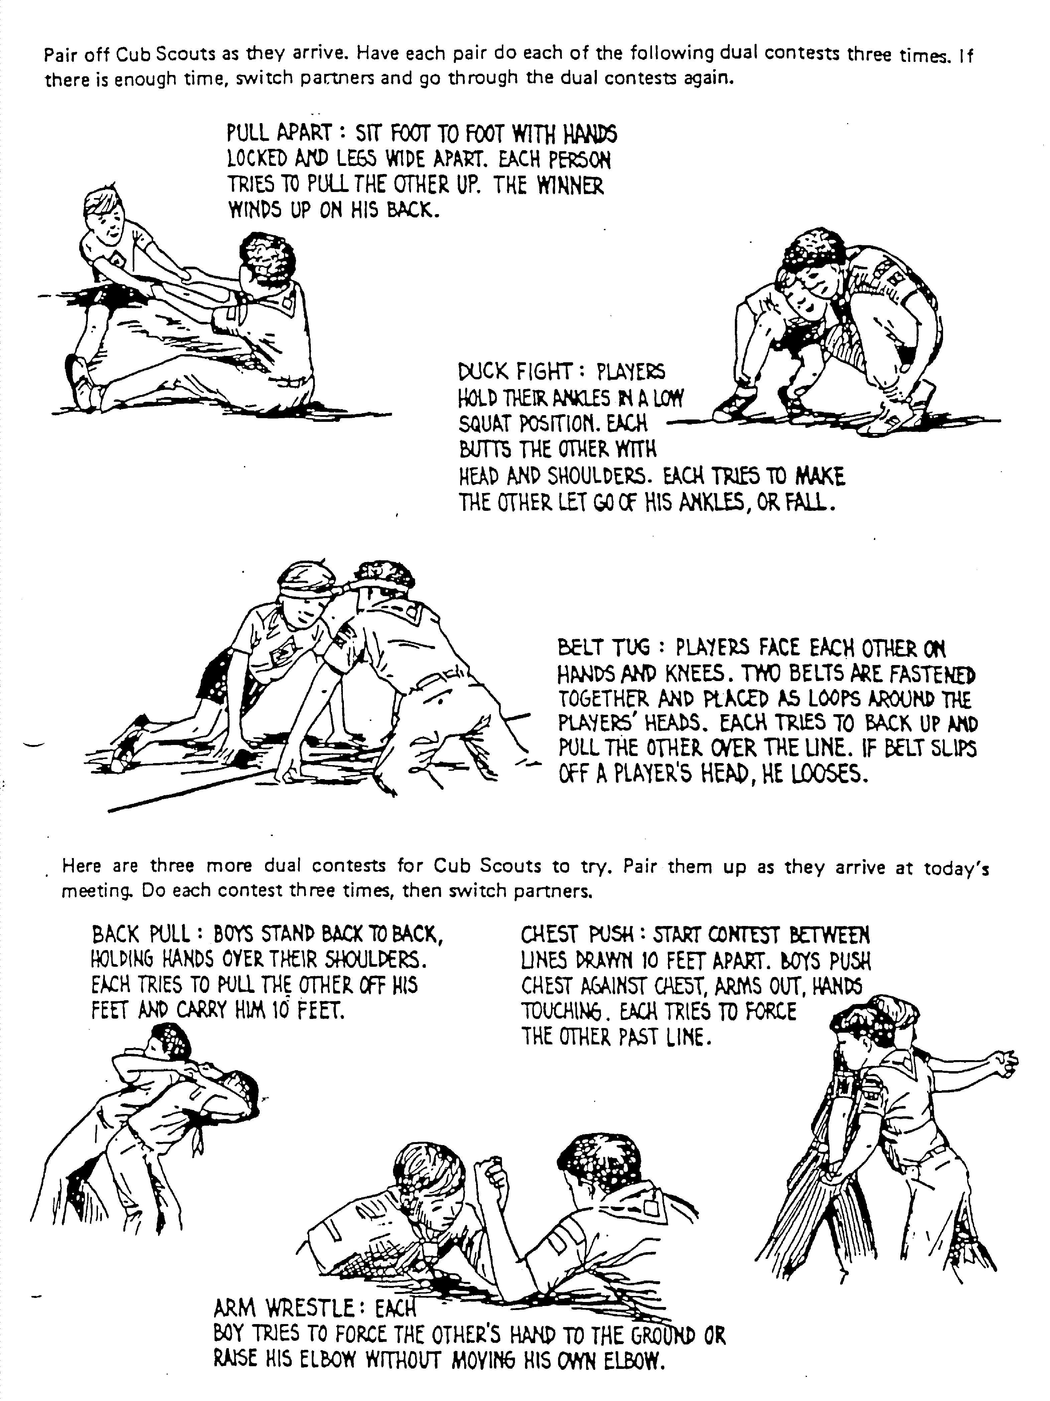

PROJECTS

Working on den projects is the primary purpose of most den meetings and occupies most of the den meeting time. A suitable den project can be almost any activity that is age-appropriate for the scouts of the den, occupies the scouts’ attention, and is fun and challenging for them to do. Example den projects on the following pages are making puppets, making kites, making bird houses, and learning to do magic tricks.

When doing projects remember:

Safety first! Make sure you and the scouts follow all of the safety rules of your den and in the Guide to Safe Scouting. Be careful with tools. Be sure the Den Leader supervises all projects using tools. Remember even scissors and pencils can be unsafe if not used properly. Show scouts how to do the project safely then watch them carefully and help when it is needed.

Plan for the project before the den meeting. Make sure project materials are available for every scout. Prepare the materials well before the meeting if necessary.

Rehearse! Make sure you know how to do the project yourself, and make sure you are comfortable demonstrating to others how to do it. Do not assume “it will be easy.” Practice beforehand.

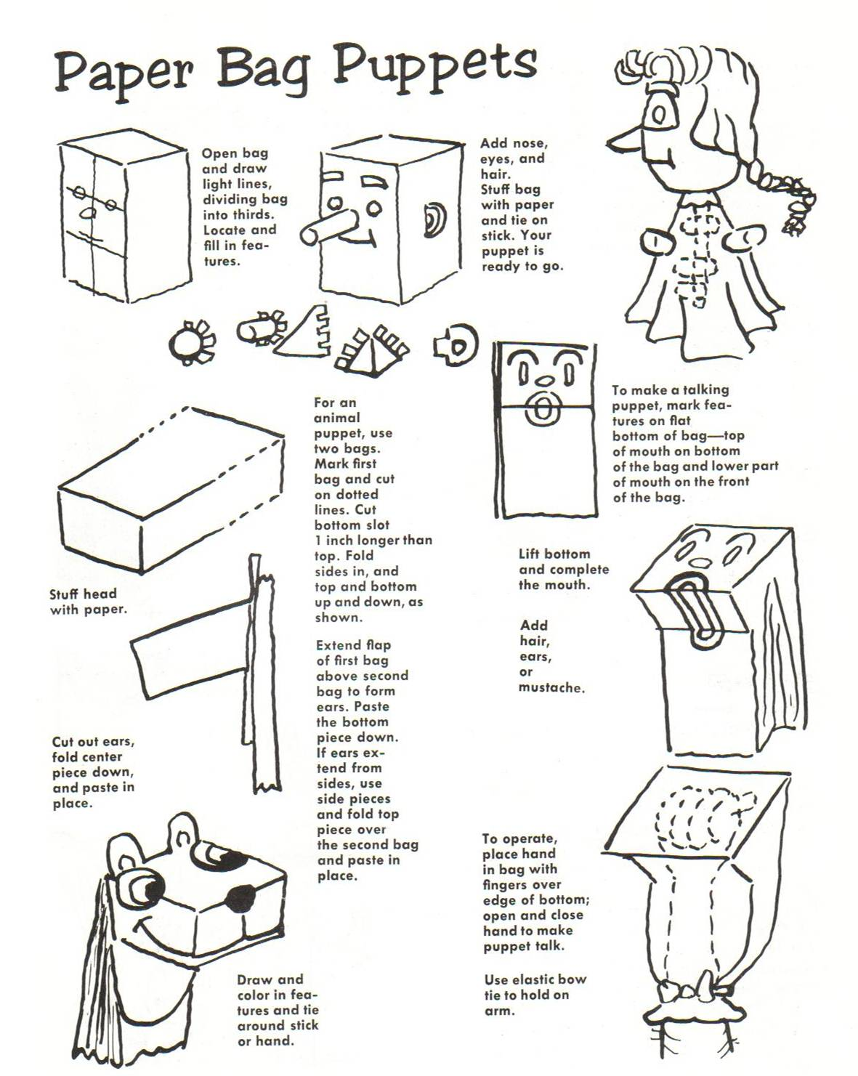

(Source: Skits and Puppets, Pow Wow Series, Boy Scouts of America, North Brunswick, NJ, 1963, p. 25.)

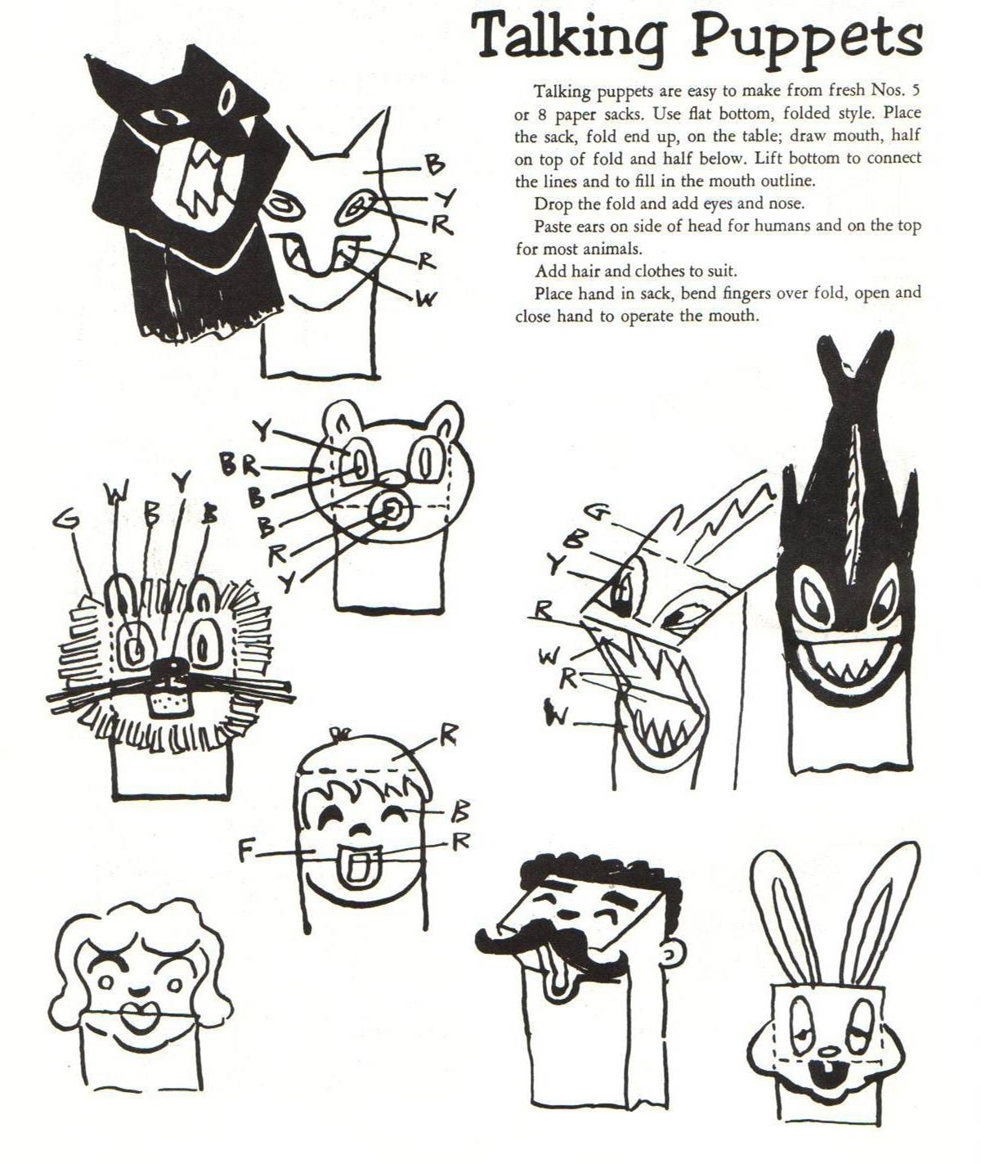

(Source: Skits and Puppets, Pow Wow Series, Boy Scouts of America, North Brunswick, NJ, 1963, p. 26.)

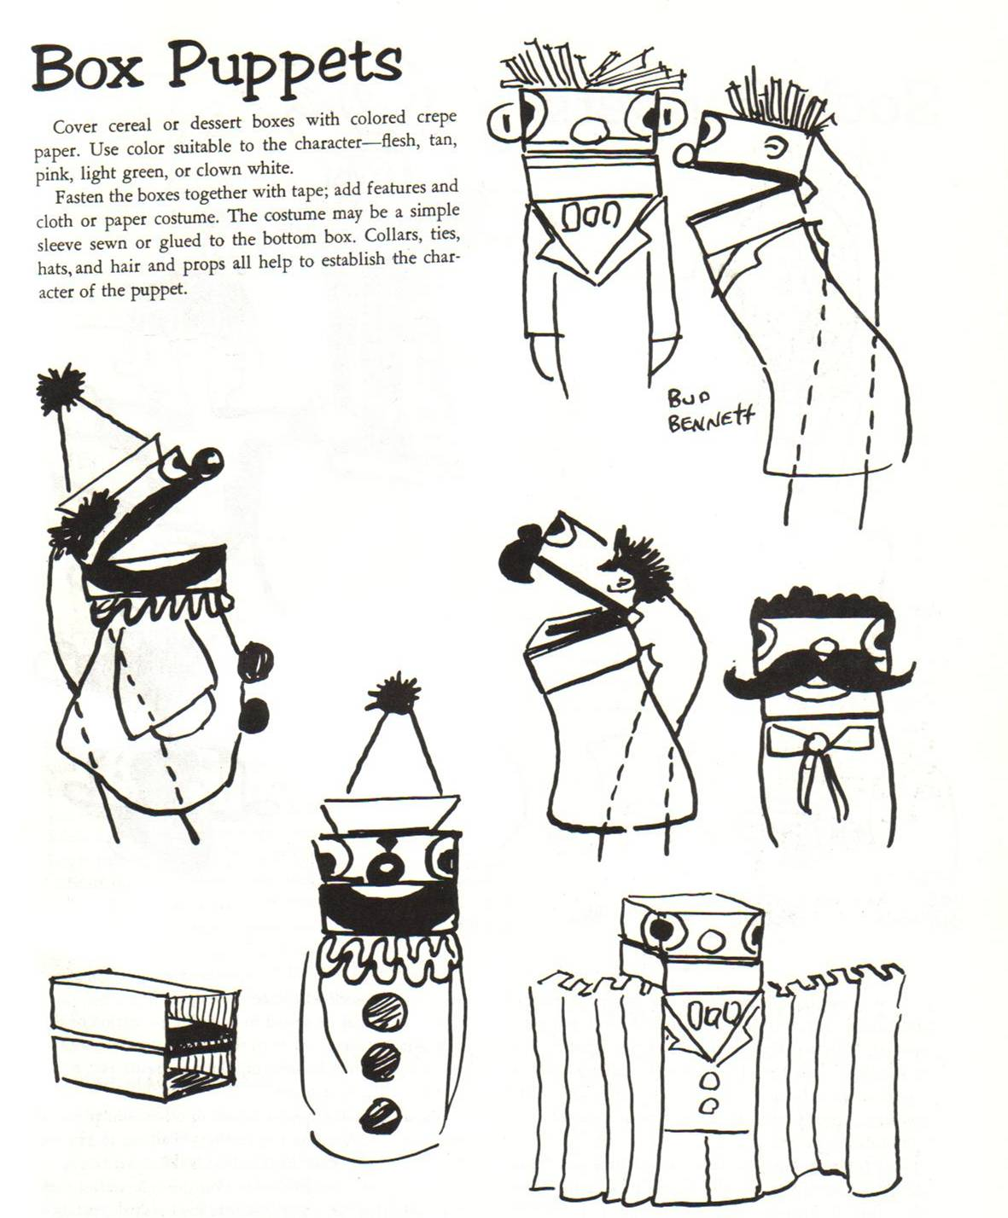

(Source: Skits and Puppets, Pow Wow Series, Boy Scouts of America, North Brunswick, NJ, 1963, p. 27.)
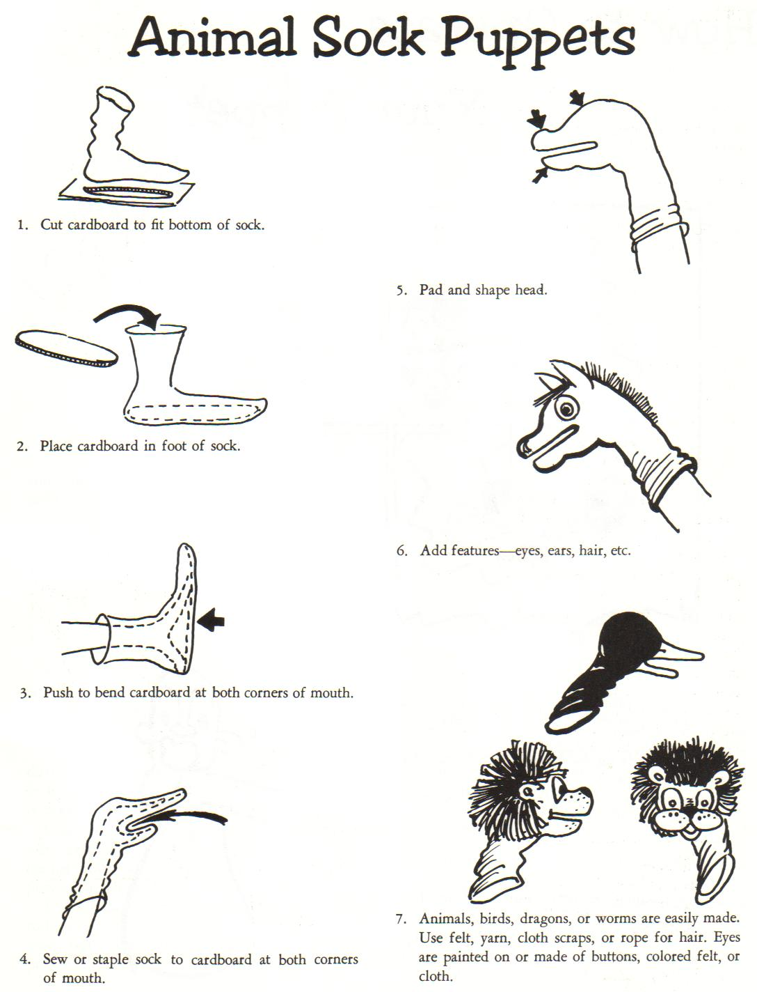

(Source: Skits and Puppets, Pow Wow Series, Boy Scouts of America, North Brunswick, NJ, 1963, p. 31.)

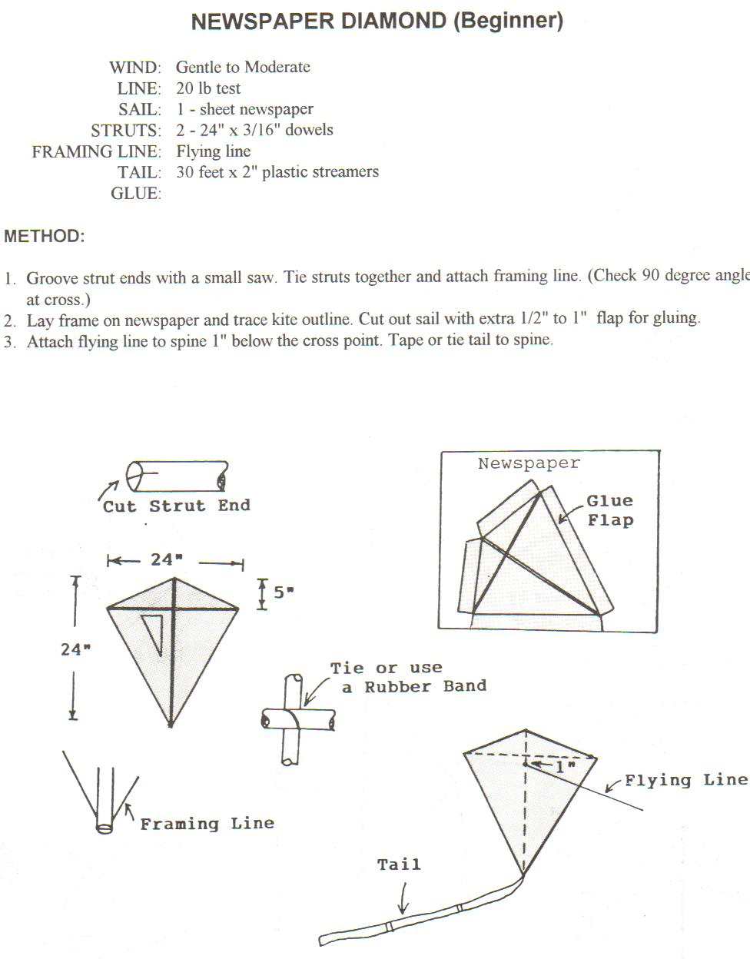

(Source: Kites in the Classroom, Wayne Hosking, American Kitefliers Association, Rockville, MD, 1992, p. 27.)

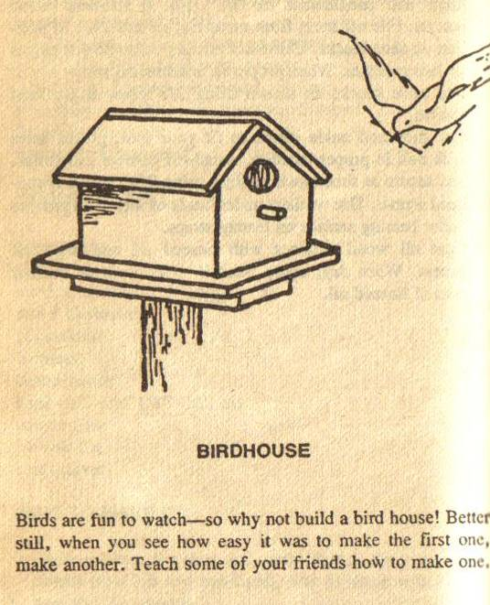
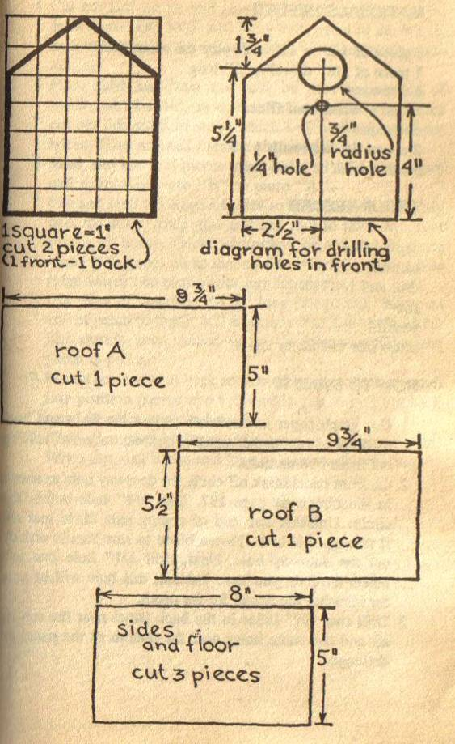

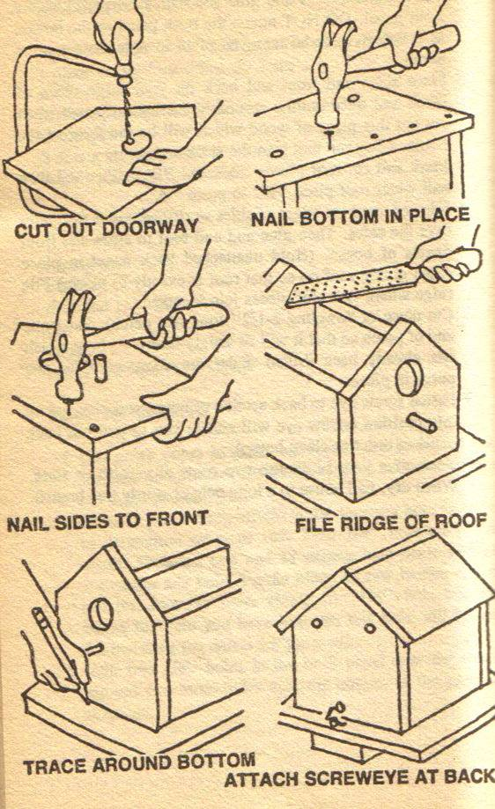

Build a Bird House – Directions

Materials
1 foot x 5 foot length of ½-inch pine
3-inch length of 3/8-inch diameter dowel
screw eye
Elmer’s waterproof glue
sandpaper
two dozen inch-long flat head nails
wood stain

Tools
saw and coping saw
hammer
drill and ¼-inch bit
file
brush for stain
How to Make the Bird House

  - Remember Safety First! Do not allow Cub Scouts to use the tools without supervision. Do not work on the bird house without the Den Leader supervising the activity. The Den Leader may not want Cub Scouts using the saws. Make sure the Cub Scouts work carefully, one step at a time, always keeping an eye on safety. Do not be in a hurry.
  - Use graph paper and mark off the outline for the front and back sections. Transfer the outlines to the pine and cut out these two sections. Careful using the saw.
  - Mark of the circle for the bird hole on the front section. Drill a ¼-inch hole inside the circle. With the Den Leader’s help, set up the coping saw inside the hole you drilled. Cut out the bird hole using the coping saw. Careful using the saw.
  - Drill a ¼-inch hole one inch below the bird hole. This will be for the dowel for the bird perch.
  - Drill two ¼-inch holes in the back section near the top. These holes are for air for the birds. Drill two more holes near the bottom of the back section. These holes are for water drainage when it rains.
  - Cut out the sides and glue and nail these pieces to the front section. Do not glue and nail the back section. We want to be able to remove the back section to clean the bird house.
  - Put the sides, front and back on the large piece of pine you have left and trace all the way around the bird house. Now cut out this piece of wood to make the floor of the bird house. Make sure it’s lined up nicely, then glue and nail the floor to the sides and front (remember – not the back!).
  - Mark and cut out the roof pieces A and B. Glue and then nail the wider roof piece B to piece A.
  - File and sand the top edges of the sides so that the roof fits snugly. Then glue and nail the roof to the sides and front (not the back!). File the ridge where the two roof pieces meet.
  - Cut a piece of dowel 2½ inches long. Sand one end so it will fit snugly into the ¼-inch hole you drilled in the front section. Glue the perch in place.
  - Fasten the screw eye to the back section of the bird house and push the back section into position. The screw eye gives you something to grab when you want to remove the back section to clean the bird house.
  - Now give your bird house two coats of stain. When dry, nail the bird house to a long pole or a sturdy tree branch.

(Source: Boy Scouts of America Workshop Book, Gene and Jody Malis, Berkley Publishing Corporation, New York, NY, 1973, pp. 186-90.)
THE CUP AND BALL TRICK

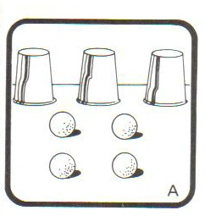
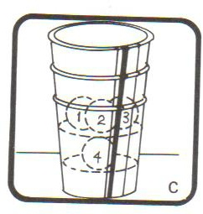
Props: Four identical soft balls (cotton
balls work well), three cups.

Stack the three cups with one ball at the
bottom of the second cup and the three
other balls in the top cup.
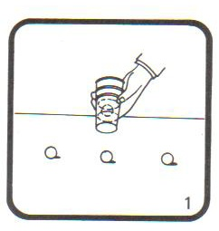
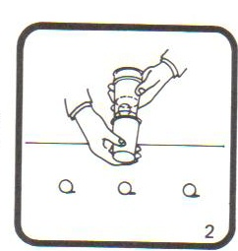
Drop the three balls out of the cup.
Line them up in a row. Hold the
stack of cups with the mouths of the
cups tilted toward you.

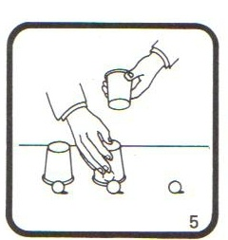
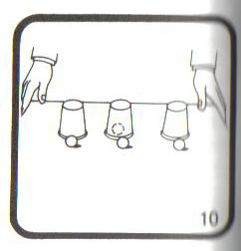
Note that the fourth ball is now under
the middle cup.

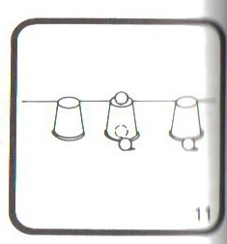
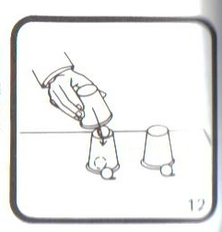
Take the ball on the right end and set it
on top of the middle cup. Restack the
three cups. Note that there is a ball hidden
between the cup on the bottom of the
stack and the cup on top of it.
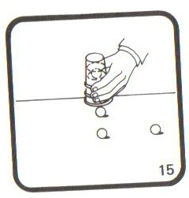
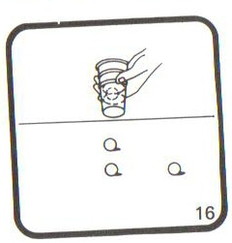

Tap the top cup and lift the stack.
Abracadabra – it looks as though the ball
you set on top of the middle cup magically
passed through that cup and wound up on
the table!

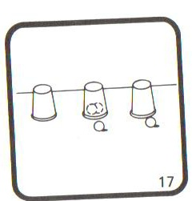
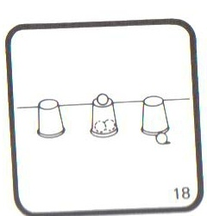
Again tilt the stack of cups with the
mouths of the cups tilted toward you.
Set the cups down one at a time, covering
the ball you just revealed. Note that now
there are two balls hidden under the
middle cup, and the other two balls are in
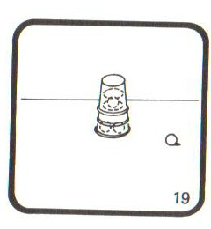
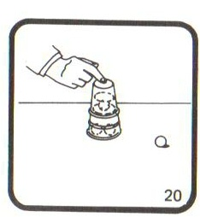
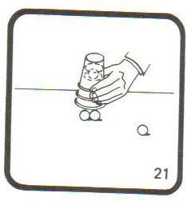
front of the middle and left-hand cups. Take one of the two balls in front of those cups and place it on top of the middle cup.

Repeat the same process
as you did before. Again
it will appear as though a
ball has magically passed
through the bottom cup of
your stack, and you will now reveal two balls underneath.
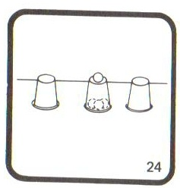
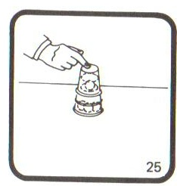
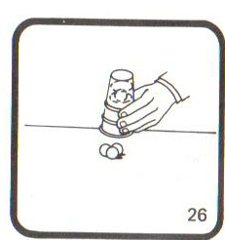
Repeat the same process
yet a third time. This time
you will reveal three balls
underneath. It will look as
though all three balls, one at
a time, magically passed
through a cup to wind up on the table underneath your stack!

(Source: Mark Wilson’s Complete Course in Magic, Mark Wilson, Ottenheimer Publishers, Inc., Philadelphia, PA, 1988, pp. 425-7.)

MAGICAL COMPARTMENT BAG
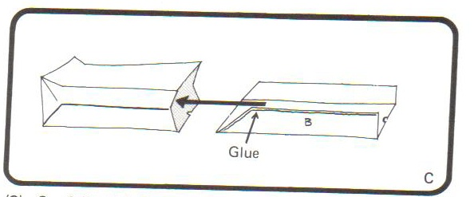

Needed: Two brown paper lunch
Bags, scissors, Elmer’s glue.

Cut along the seam of one bag to
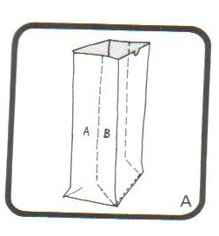
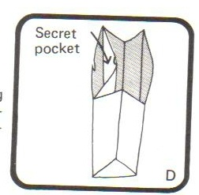
make the half-bag shown on the
right. Spread glue on the left and
right edges and insert into the
second bag as shown. Press the
glued edges to the wall of the
second bag and let dry.
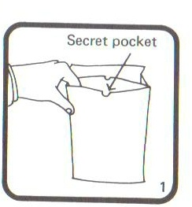

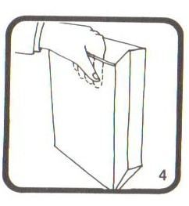
The compartment bag can be

used to make an object magically

disappear, or to transform an

object into another object. For

example, hold the bag with the

secret compartment closed by your

left hand as shown. Show the

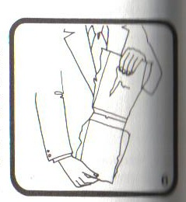
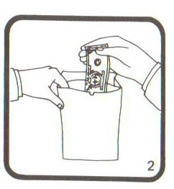
audience the inside of the main

compartment and say it’s just an

empty bag. Now carefully open

the secret compartment, without

the audience seeing, and drop a

dollar bill inside. Close the bag

off, shake it, say your magic word,

and show the audience the main compartment of the bag. The dollar bill has

magically disappeared! To prove your point, tear open the front of the bag to

open up the main compartment – there is nothing there! Of course your dollar

bill is in the secret compartment.

(Source: Mark Wilson’s Complete Course in Magic, Mark Wilson, Ottenheimer Publishers, Inc., Philadelphia, PA, 1988, pp. 357-9.)

CEREMONIES

Ceremonies have a number of purposes:

- Announce the beginning or ending of a meeting
- Honor our country, our flag, those who fought for freedom
- Remind scouts about promise/law, scouting values/responsibilities
- Recognize and honor those who are receiving awards

Ceremonies should be a part of every meeting.

Who leads? Cubmaster, Den Leader, Den Chief, even Cub/Webelos Scouts.

How long? Long enough to be special, short enough to hold attention.

Props: add color and life to ceremonies. Flags, candles, lights, emblems, signs, costumes, den doodles, even music! Use your imagination!

Good Ceremonies:
- Based on scouting ideals
- Well planned and rehearsed
- Well-staged, good spirit
- Colorful, inspirational, sincere
- Scouts speak loud enough to be heard!

Resources:
- Den Chief Handbook
- Staging Den and Pack Ceremonies
- Roundtable handouts
- Cub Scout Program Helps

STANDARD FLAG CEREMONY

Personnel: Flag bearers for the American flag and Pack flag, color guard for each flag, and a leader.

Equipment: American flag, Pack flag, flag stands.

Arrangements: Flag stands are in place in the front of the room. Flag bearers and color guards are in position in the rear of the room. The leader, who gives the commands, may be in the rear of the room or in a convenient place nearby. The Cubmaster usually calls the meeting to order and introduces the Den that will perform the opening ceremony. Upon introduction the leader moves to the front of the room.

Leader: Commands should be given sharply and loudly. “Cub Scouts….Attention! Will the audience please rise for the presentation of the colors? Color guard, present the colors!”

Color Guard: The color guard advances from the rear of the room with the flag bearers slightly in front, following the guards. The American flag should be on the right as viewed from the rear of the room. As the procession begins, the leader gives the next command.

Leader: “Hand salute!” Leader salutes and the audience does likewise. All leaders in uniform should salute, anyone in civilian attire should place hand on heart. The leader’s eyes follow the American flag until it is in position in the front of the room.

Color Guard: As the American flag reaches the front of the room, the bearer crosses over to the audience’s left and the bearer of the Pack flag crosses over to the audience’s right. The flag bearers and color guards take their positions in front of the room near their respective flag stands. Bearers and guards stand at attention, facing the audience. The flags are held vertically.

Leader: “Please repeat the Pledge of Allegiance. I pledge allegiance….”

Color Guard: Upon the start of the pledge, the Pack flag is lowered at a slight angle, taking care not to touch the floor, and full attention is given to the American flag. Flag bearers and guards do not salute or repeat the pledge. When the Pledge of Allegiance is finished the leader gives the next command.

Leader: “Two!” This is the signal for all salutes to be dropped. “Color guard, post the colors!”

Color Guard: The Pack flag is raised to the vertical position again. The Pack flag is placed in its stand. The bearer and guards salute it and step back into place. The American flag is placed in its stand and its bearer and guards salute it, then step back into place.

Leader: “Color guard, retreat!”

Color Guard: Flag bearers lead the procession to the back of the room with the leader following last.

Enhancements – The standard flag ceremony can be enhanced by singing the “Star Spangled Banner” in place of the Pledge of Allegiance,” and/or by having the leader read or recite and patriotic reading. This reading could be a brief text or poem about the flag in general, such as:

The flag is the symbol of our country,
Long and proud may it wave;
For those who fought and died for freedom,
We forget not what they gave;
So no matter what our cares are,
No matter our pains and hurts and gripes,
Our flag reminds us all of freedom's cost,
And we salute you Stars and Stripes!

SOME IDEAS FOR CEREMONIES YOU MIGHT USE IN YOUR DEN MEETINGS

Cub Scout/Den Chief Handshake – The Den Chief calls the roll, and each scout comes forward and gives the handshake.

Uniform Inspection – for neatness and correct placement of insignia.

A Special Cub Scout Song, Yell, or Cheer.

Patriotic Song – Singing “America” or “God Bless America” is a good way to end a meeting.

Circle Handclasp – The Cub Scouts form a circle and one-by-one they pass along the scout handclasp until it has reached the scout who started it. As each scout receives the handclasp he makes a wish and says, “Do your best.”

Cub Scout Living Circle – The Den stands in a living circle and repeats in unison the Cub Scout Promise, Law of the Pack, or Cub Scout Motto. The living circle is as follows: the Den forms a circle facing inward. The scouts turn slightly to the right, and each extends his left hand into the circle, palm downward and left thumb pointing to the right. Each scout grasps the extended thumb of the scout to the left, making a circle of hands grasping thumbs. The right hand is held high in the Cub Scout sign.

Friendship Circle – Each scout has a 3-foot section of rope joined with a square knot to the rope of the scout on his left. The scouts hold the rope with their left hands and pull back to form a taut circle. The Den Chief says, “You are now part of a group of close friends, held together by a square knot, a symbol of friendship. Let’s give the Cub Scout Promise.” Or the Den Chief might recite the following poem:

The Magic Rope

I picked some scraps of rope apart
To see how they were made.
Most of it was twisted hemp
Yet some was cotton braid.

And from the stuff I played with
I thought aloud, “Rope size runs
To hawsers that hold battleships
Of fifty-thousand tons.

But there’s another kind of rope
Not made by a machine,
Stronger than the best steel cable
Yet so fine it can’t be seen.

I’m not talking about the kind of rope
That anybody buys,
But the magic line of friendship
That holds two friendly guys.

I learned a lot of things at camp
But the best trick that I got
Was to take that line of friendship
And tie the proper knot.

A Prayer – Choose one suitable for all faiths. A good closing ceremony is reciting the following brief prayer:

Now as I start upon my chosen way,
In all I do, my thoughts, my work, my play,
Grant as I promise courage new for me,
To be the best, the best that I can be.

May the Great Master of All Scouts be with us until we meet again.
