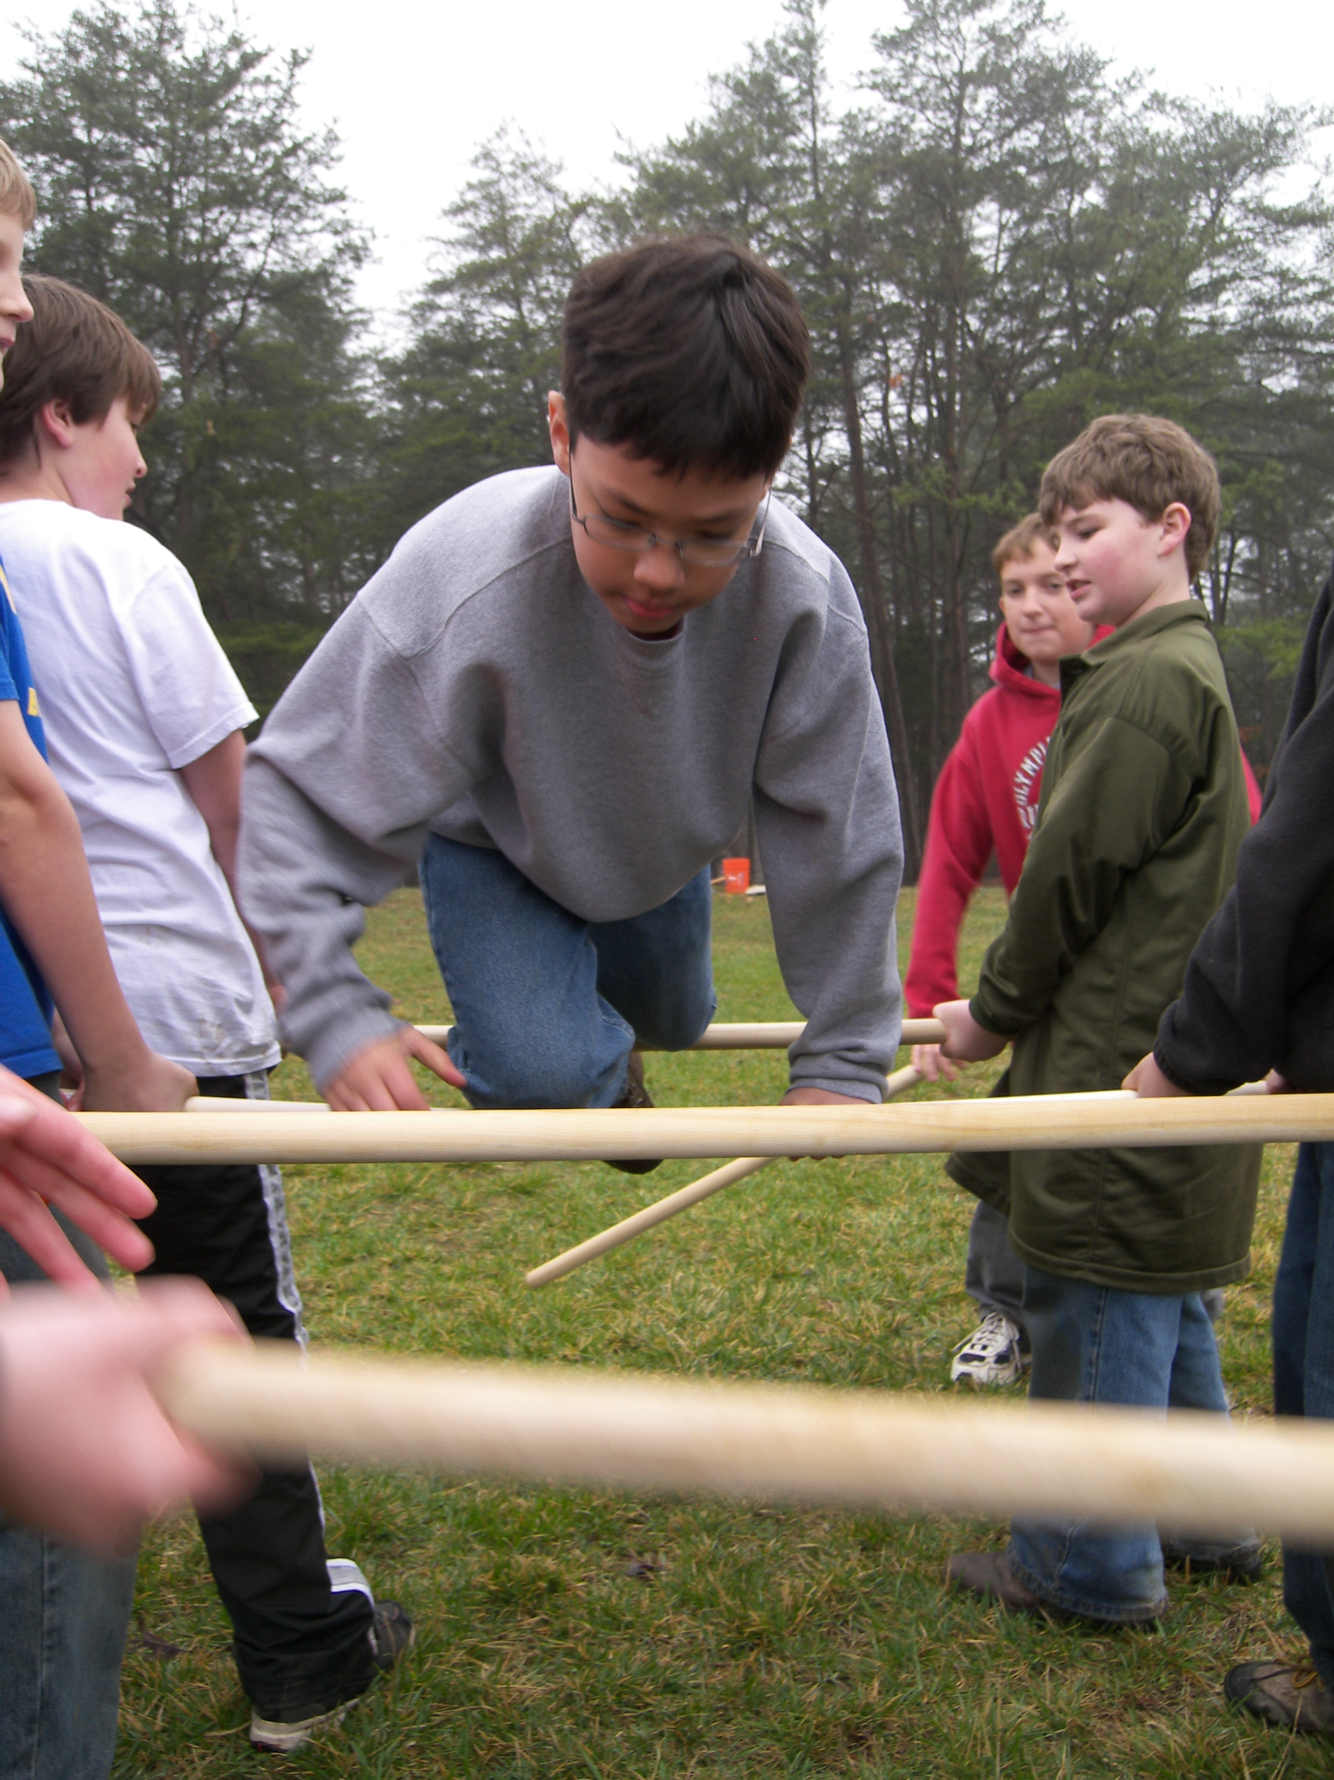

IN TROOP 1570, CHARACTER COUNTS!

Every scout who takes the Boy Scout Oath and Law is committing himself to practicing many virtues and thereby growing his character, but exactly what are virtues and what is character? On March 23-25 at Lake Fairfax Park, Troop 1570 held its first annual Character Campout for its new scouts and for those scouts with the troop one year or less. During the campout the scouts explored the meaning of virtue and character and their importance not only to the individual scout and his happiness, but also to the performance and success of his patrol. Scouts learned that virtues are good habits that make up one’s character, and that one can be virtuous only be performing virtuous acts. The scouts participated in a number of interactive and reflective games and activities, including a Virtues/Vices Game in which scouts learned about the virtues embedded in the Scout Oath and Law, and how these virtues represent a Golden Mean of in-control behavior between vices in deficiency and excess, such as “A Scout is Brave” means that a scout is neither cowardly nor reckless. Scouts then saw how their virtues composite their character, and that each person’s “Snowflake of Character” is unique and special and deserving of respect. Scouts also learned about making moral decisions through role-playing exercises in the Right Decisions/Right Now program materials, developed by the BSA Old Hickory Council. The importance of character to patrol performance was emphasized in a sequence of initiative/cooperative games, including Plutonium Portation, Human Ladder, Spider Web, and several others. All of these activities culminated in our new scouts earning and receiving their Scout Badges at the March 24 evening campfire. On March 25 a Scouts-Own worship service was held, followed by a troop service project at its new Adopt-A-Spot, Haley M. Smith Park. A wonderful, fun, character-building experience was had by all!

